**Minecraft Instructional Writing Challenge (Teacher Notes)**

**Context**

The students may have heard of YouTubers such as stampylonghead and CaptainSparklez, all famous for their Minecraft tutorials. But what they might not know is that, before uploading their tutorials to YouTube, they plan what they are going to say and do first as well as write down step-by-step instructions to refer back to as they record their videos.

In this lesson, students are going to take on the role of a YouTuber and create a set of step-by-step instructions for creating a simple build as if you were planning their own tutorial video.

**Challenge**

In this lesson, students are challenged to build a basic structure or simple red stone contraption and write down a set of step-by-step instructions for others to follow so that they can re-create their build.

Students are encouraged to use time connectives and include some imperative (bossy) verbs in their instructions. Some examples of time connectives and imperative verbs have been included to help students with their writing.

**Expectations**

When writing their instructions, students should:

* Include a title that explains what the instructions are for
* Have clear and simple steps that:
  + are in the correct order
  + contain imperative (bossy) verbs
  + use time connectives
* Contain pictures and/or labelled diagrams
* Include a list of items (blocks) needed to complete the build

Below are some examples of time connectives and imperative (bossy) verbs for students to use in their instructions.

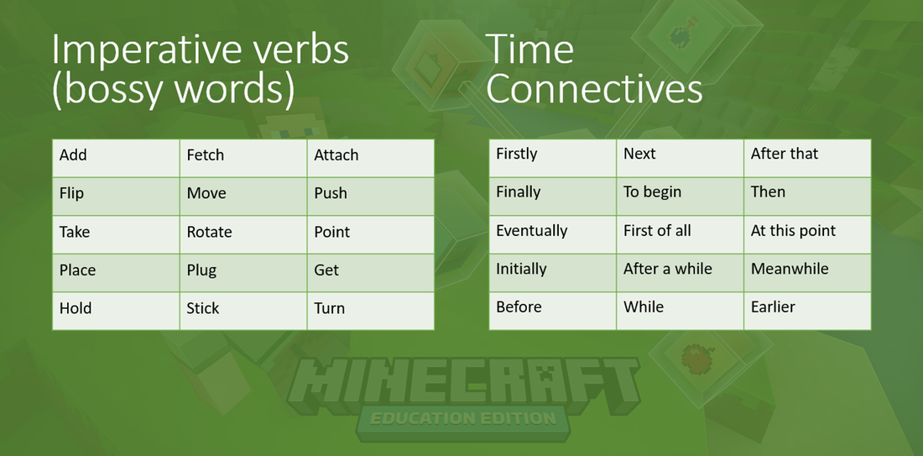

**Extension**

If time allows, students can either create a more complex build or try to follow each other’s instructions.

**Setting up the world**

For this challenge, it’s recommended that you create a new world (preferably flat). You will also need to set your new world to ‘creative’ mode. If you don’t want to be bothered by Creepers or Zombies etc. it’s also recommended that you set your world to ‘peaceful’!

To create a new world in Minecraft:

*1. Click on ‘Create New World’*

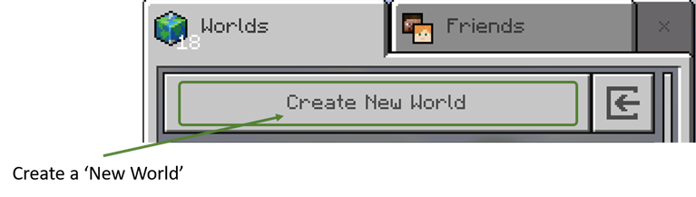

*2. Choose your world settings.*

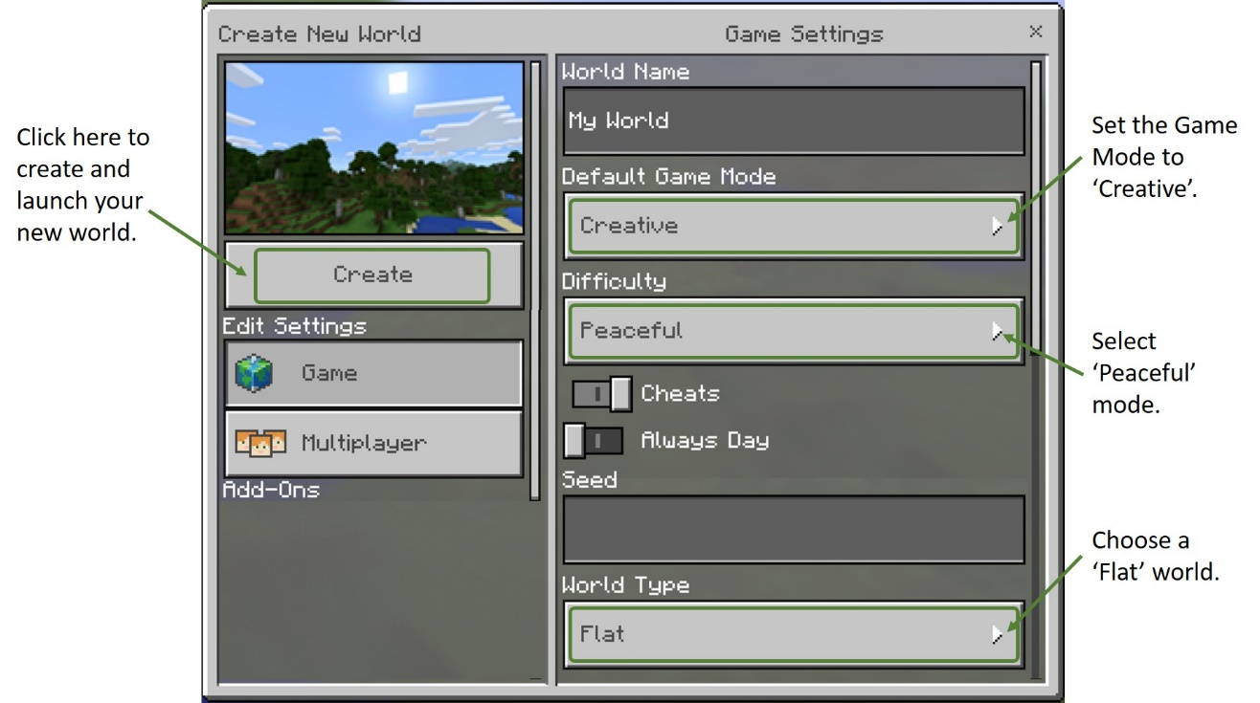

*3. Click on ‘Create’*

Alternatively, students can also use the build arena (attached world).