**Minecraft Instructional Writing Challenge.**

You may have heard of YouTubers such as stampylonghead and CaptainSparklez, all famous for their Minecraft tutorials. But did you know that, before uploading their tutorials to YouTube, they plan what they are going to say and do first as well as write down step-by-step instructions to refer back to as they record their video.

In this lesson, you’re going to take on the role of a YouTuber and create a set of step-by-step instructions for creating a simple build as if you were planning your own tutorial video.

**Challenge**

Your challenge is to build a basic structure or simple red stone contraption and write down a set of step-by-step instructions for others to follow so that they can re-create your build.

Below are some example imperative verbs (bossy words) and time connectives to include in your instructions:

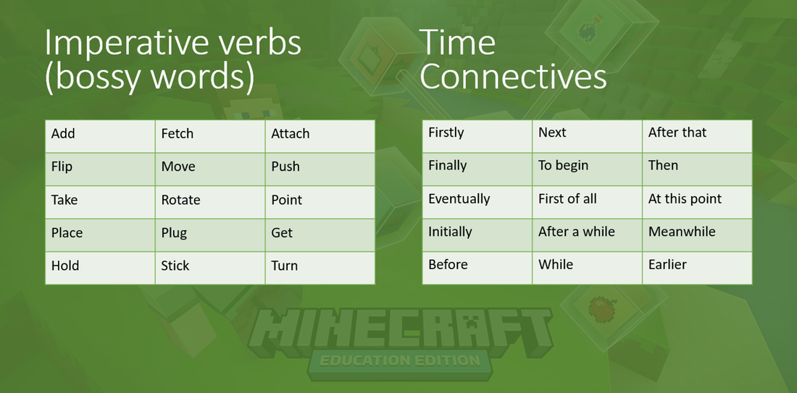

**Instructions**

For this challenge, it’s recommended that you create a new world (preferably flat). You will also need to set your new world to ‘creative’ mode. If you don’t want to be bothered by Creepers or Zombies etc. it’s also recommended that you set your world to ‘peaceful’!

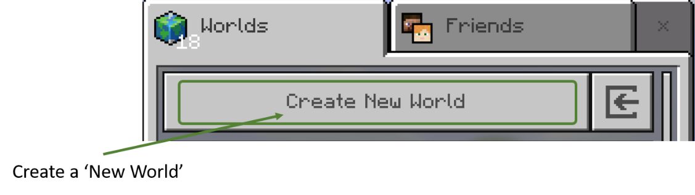

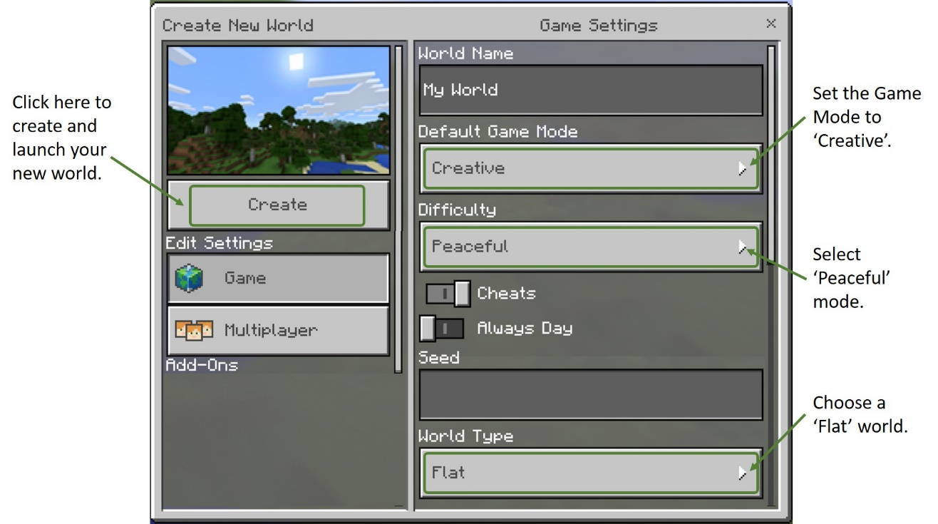

Not sure what to create? Check out the next page for some examples.

**Examples**

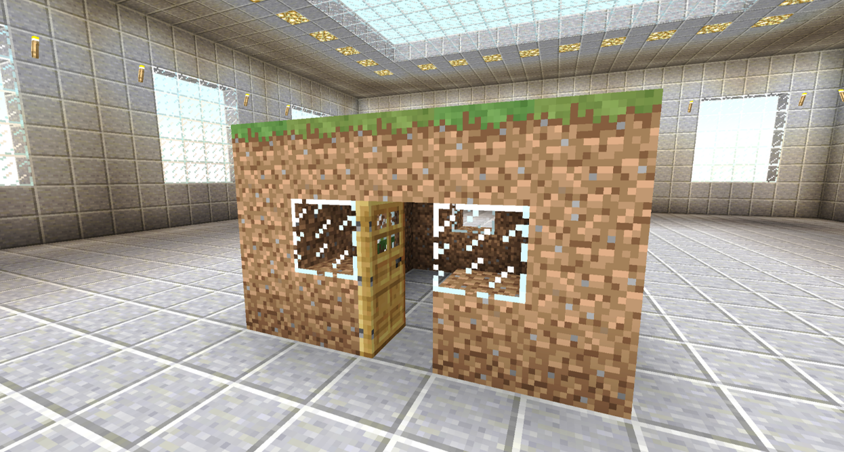

Basic house

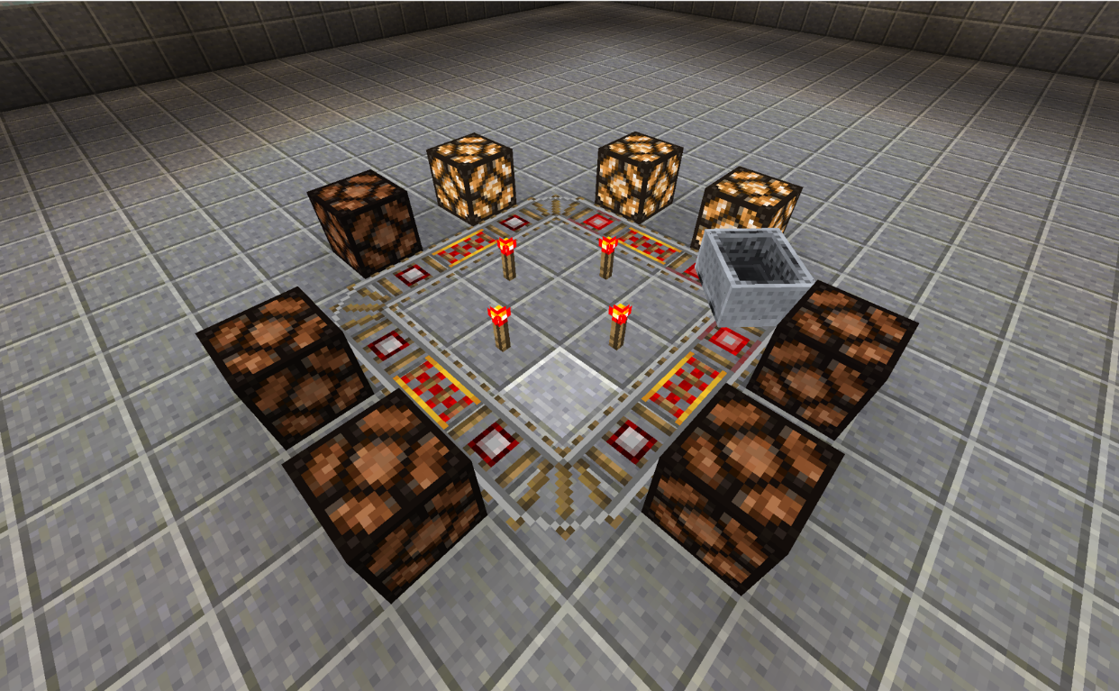

Redstone lighthouse