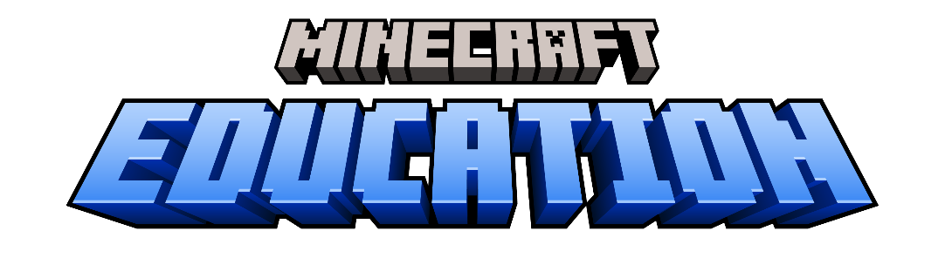

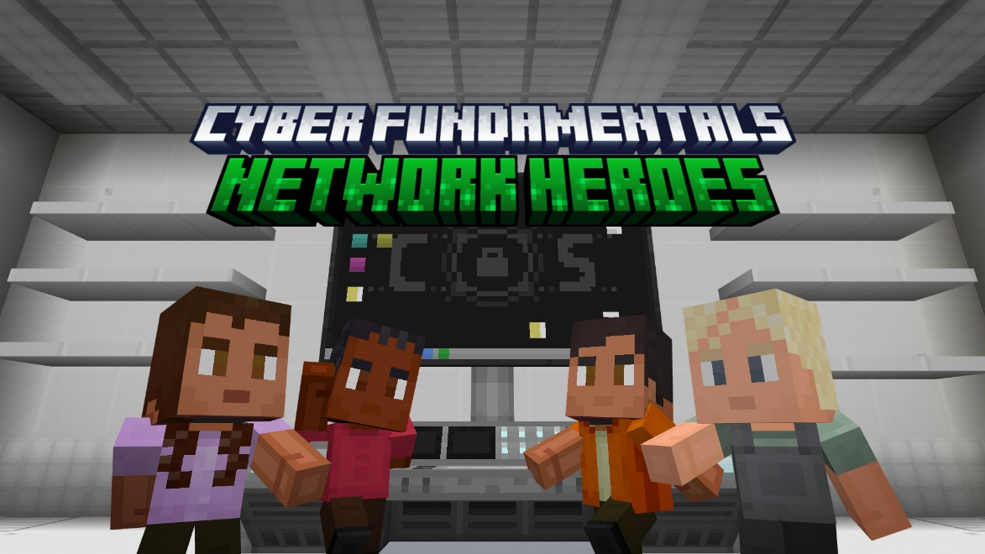

Educator Guide
Cyber FUNdamentals - Unit 1
Single Student

Network Heroes

Education.minecraft.net
THEME Overview
Cyber FUNdamentals is part of the K-12 cybersecurity progression in Minecraft Education. These lessons are designed for Lower Secondary | Grades 6-8 | Ages 11-14. Cyber FUNdamentals consists of three units, which each contain multiple lessons covering various cybersecurity concepts.
This unit is the Network Heroes. This unit contains 3 lessons:
- Network Components
- Password Protection
- Malware
UNIT Objectives
By the end of this unit, students will be able to:
- Articulate the components make up a local-area network (LAN)
- Differentiate between local area-network (LAN) and wide-area network (WAN)
- Draw and label a diagram of how information travels through a network (i.e., packets)
- Explain the importance of encryption for confidentiality
- Create complex passwords
- Describe layered security practices (such as 2FA and network firewalls) to keep unauthorized users from accessing their networks
- Define malware and identify common types of malware
- Explain how individuals can avoid malware

Educational Standards – Computer Science
CSTA Standards
Middle Grades
2-NI-04 Model the role of protocols in transmitting data across networks and the Internet.
2-NI-06 Apply multiple methods of encryption to model the secure transmission of information.

ISTE Standards
1.2.b Students engage in positive, safe, legal and ethical behavior when using technology, including social interactions online or when using networked devices.
1.2.d Students manage their personal data to maintain digital privacy and security and are aware of data-collection technology used to track their navigation online.

CYBER.ORG Standards
6-8.CS.COMP Identify the role of connected network components
6-8.CS.COMM.1 Compare and contrast network topologies.
6-8.SEC.CRYP Discuss methods and the need for encrypting information when it is being exchanged, e.g., http vs. https.
6-8.SEC.COMP Describe Defense in Depth strategies to protect simple networks.
6-8.SEC.CIA Explain the effects of a failure of the CIA Triad

Computing programmes of study – Key Stage 3
Understand a range of ways to use technology safely, respectfully, responsibly and securely, including protecting their online identity and privacy; recognise inappropriate content, contact and conduct and know how to report concerns.
Australian f-10 Curriculum: Digital Technologies – Year 7 & 8
Plan and manage projects that create and communicate ideas and information collaboratively online, taking safety and social contexts into account (ACTDIP032)

Ways to use this learning content
How can this lesson be used?
Integrated into classrooms | Cyber FUNdamentals is connected to numerous computer science, technology, and cybersecurity standards. You could easily look at your academic standards and use this learning content when you are teaching specific concepts related to digital citizenship, networks, or online safety. This learning content is a great way to introduce and support cybersecurity concepts.
STEAM Labs or Digital Makerspaces | Who wouldn’t love to use Minecraft in a fully integrated learning environment where everything from the furniture and technology to curriculum and assessment work together to support hands-on, minds-on learning?! Cyber FUNdamentals content could be used in any of the learning spaces to create safe and responsible digital citizens.
Afterschool learning opportunities | After a full instructional day, students need something fun and engaging to provide motivation for learning. What could possibly be more fun and engaging than Minecraft Education?! Not only will students love playing Minecraft, but they will also learn educational concepts and develop their skills in creativity, communication, collaboration, and critical thinking.
Summer camps | Are you planning or hosting a summer camp? Who wouldn’t love to explore and learn in Minecraft?! Whether Minecraft is the entire theme of the camp or even simply a portion of the camp, there are numerous opportunities for Minecraft Education to be a part a fun-filled summer experience!
Homeschool groups and other youth organizations | You don’t have to be exclusively at a school or part of a school district to utilize Minecraft Education. Homeschools, families, and other organizations can purchase and manage Minecraft Education through our commercial offer. You can find more information here.

Network Heroes — Lesson Activities
Overview of the Lessons

Beginning the Map
When the world launches, players will immediately be prompted to select their control scheme: keyboard or touch controls.

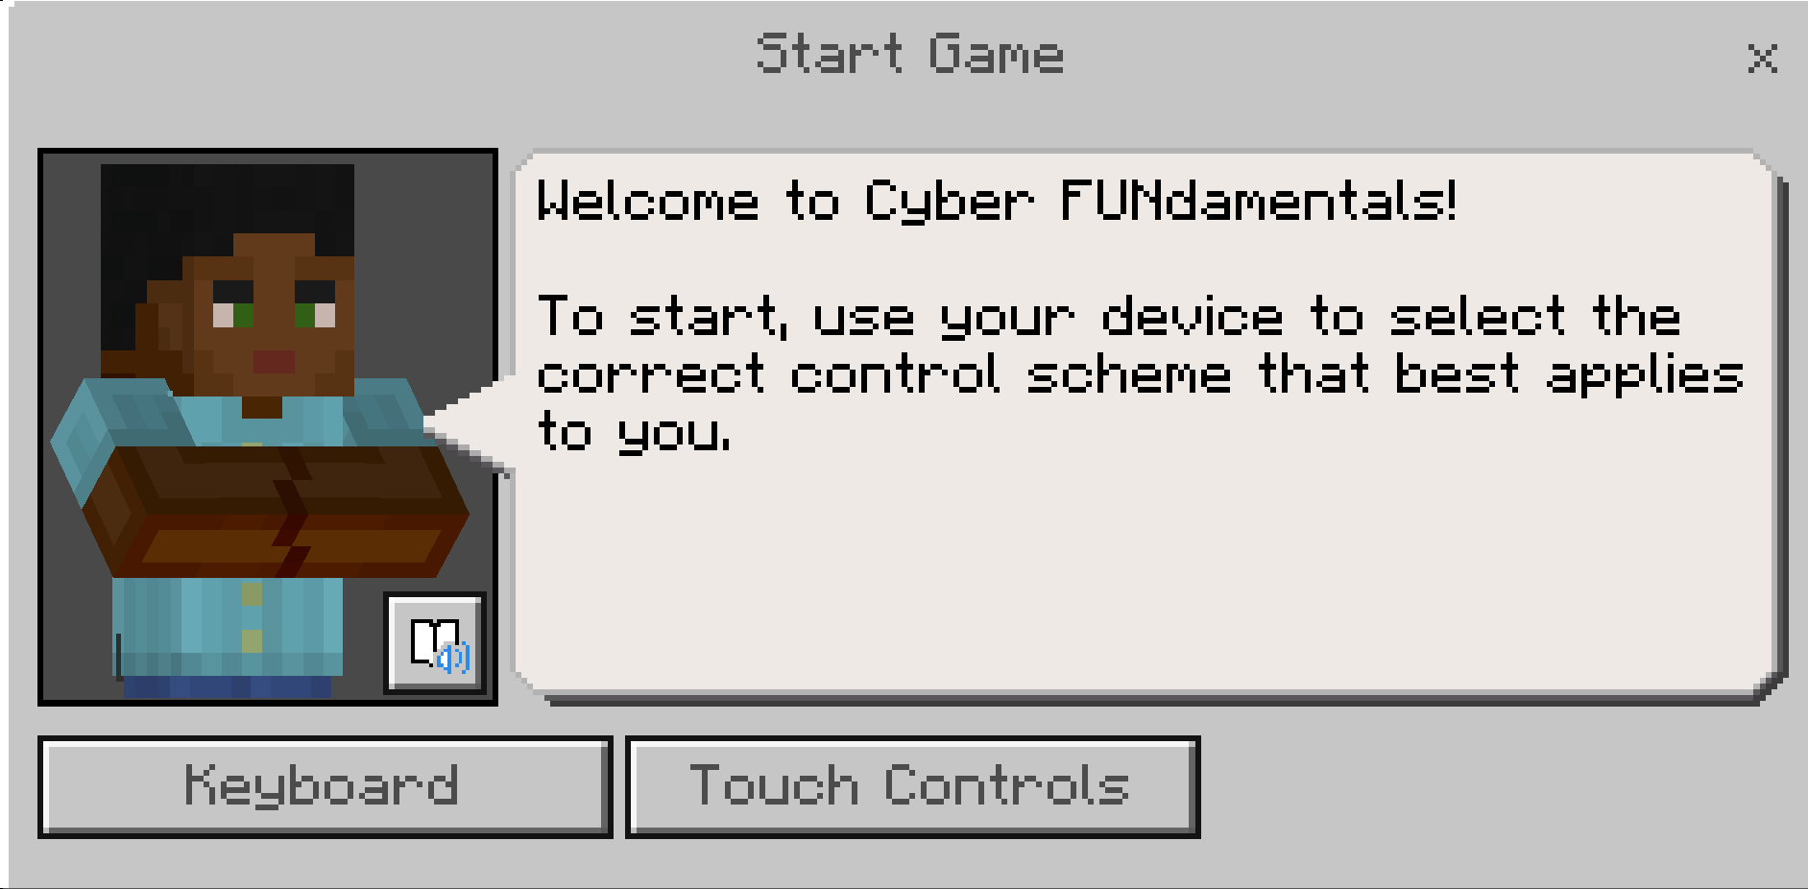

The player will receive another message, which will ask the player to verify their control scheme. Based on their selection, they will need to confirm by selecting “Yes, it is!” or they will need to select “No, it’s not.” if they selected the wrong scheme.

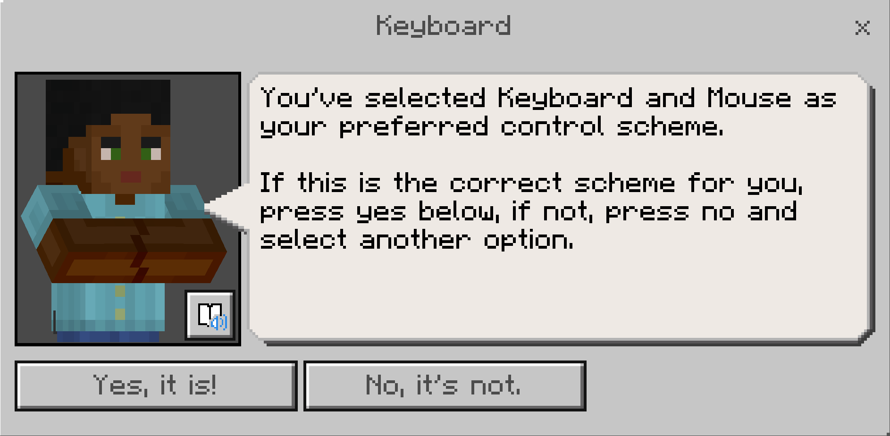

Next, players will be prompted with the question of, “Is this your first time playing Minecraft?”

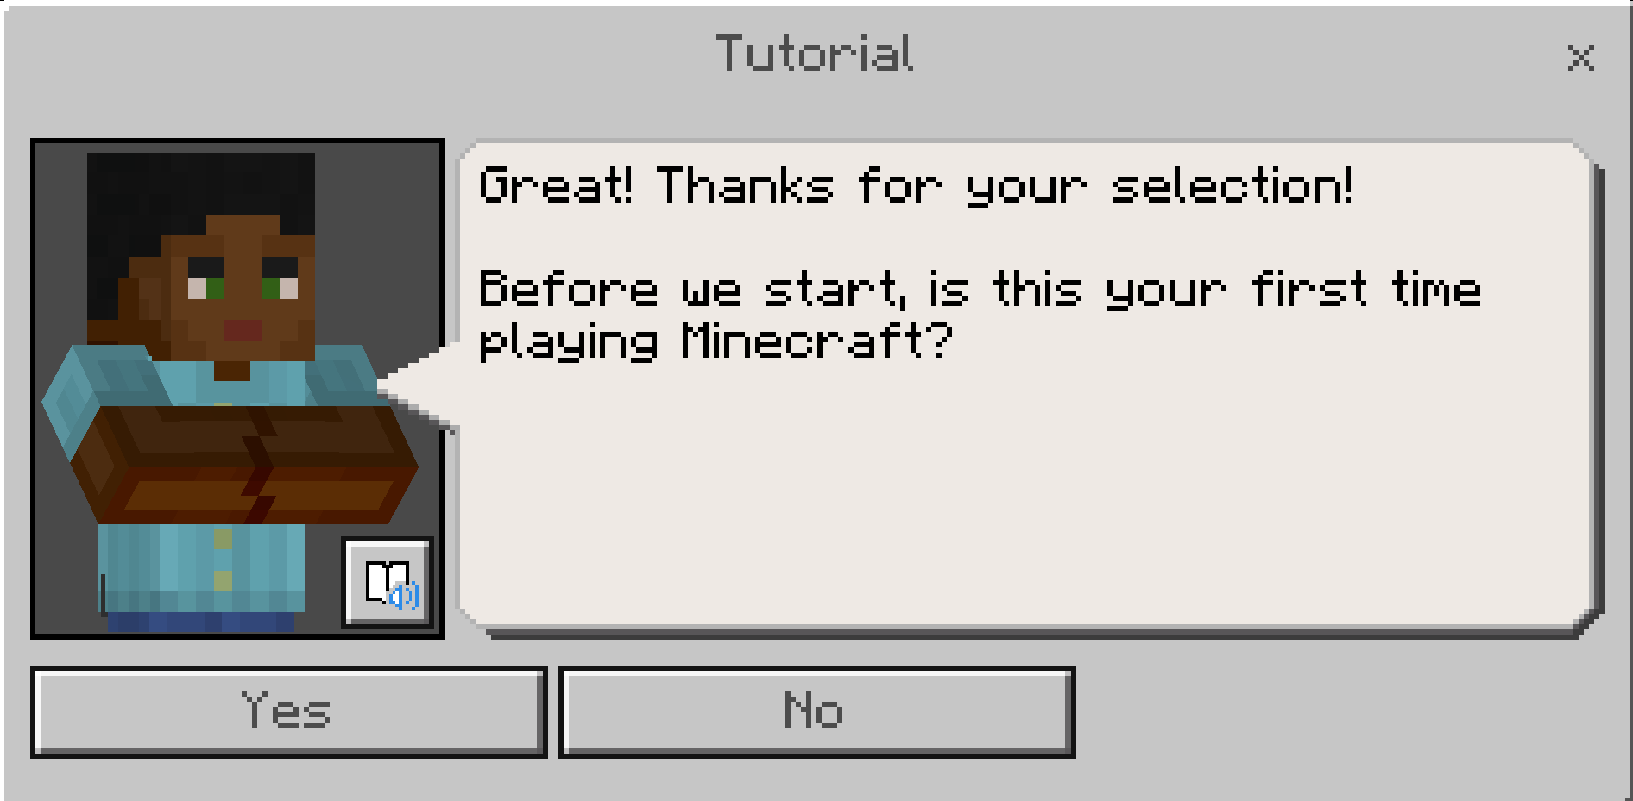
If players select “Yes”, they will proceed to a tutorial of game play mechanics. If they select “No”, they will proceed to the start of the game.

Tutorial Sequence
KEYBOARD | TOUCH CONTROLS
Task 1: Look at the golden orbs

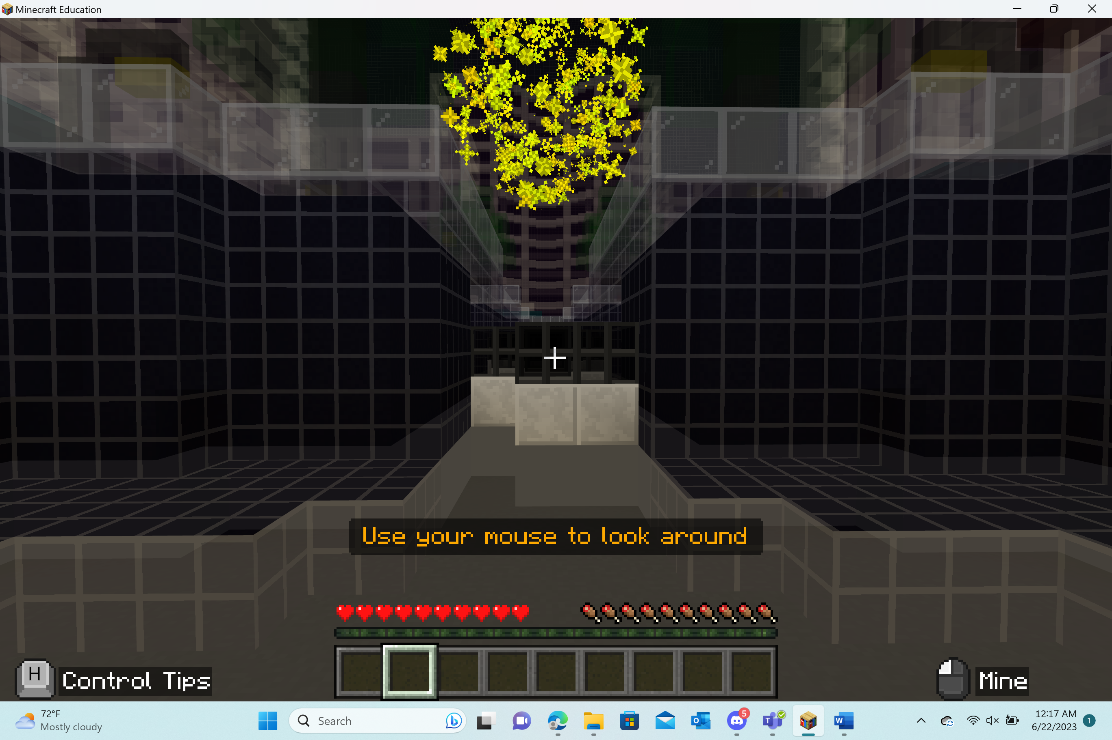  Players will need to use their mouse and place the “+” (crosshairs) on the golden orbs. The player should look at the golden orb until it disappears. They will look at 9 golden orbs before moving on to the next task. | 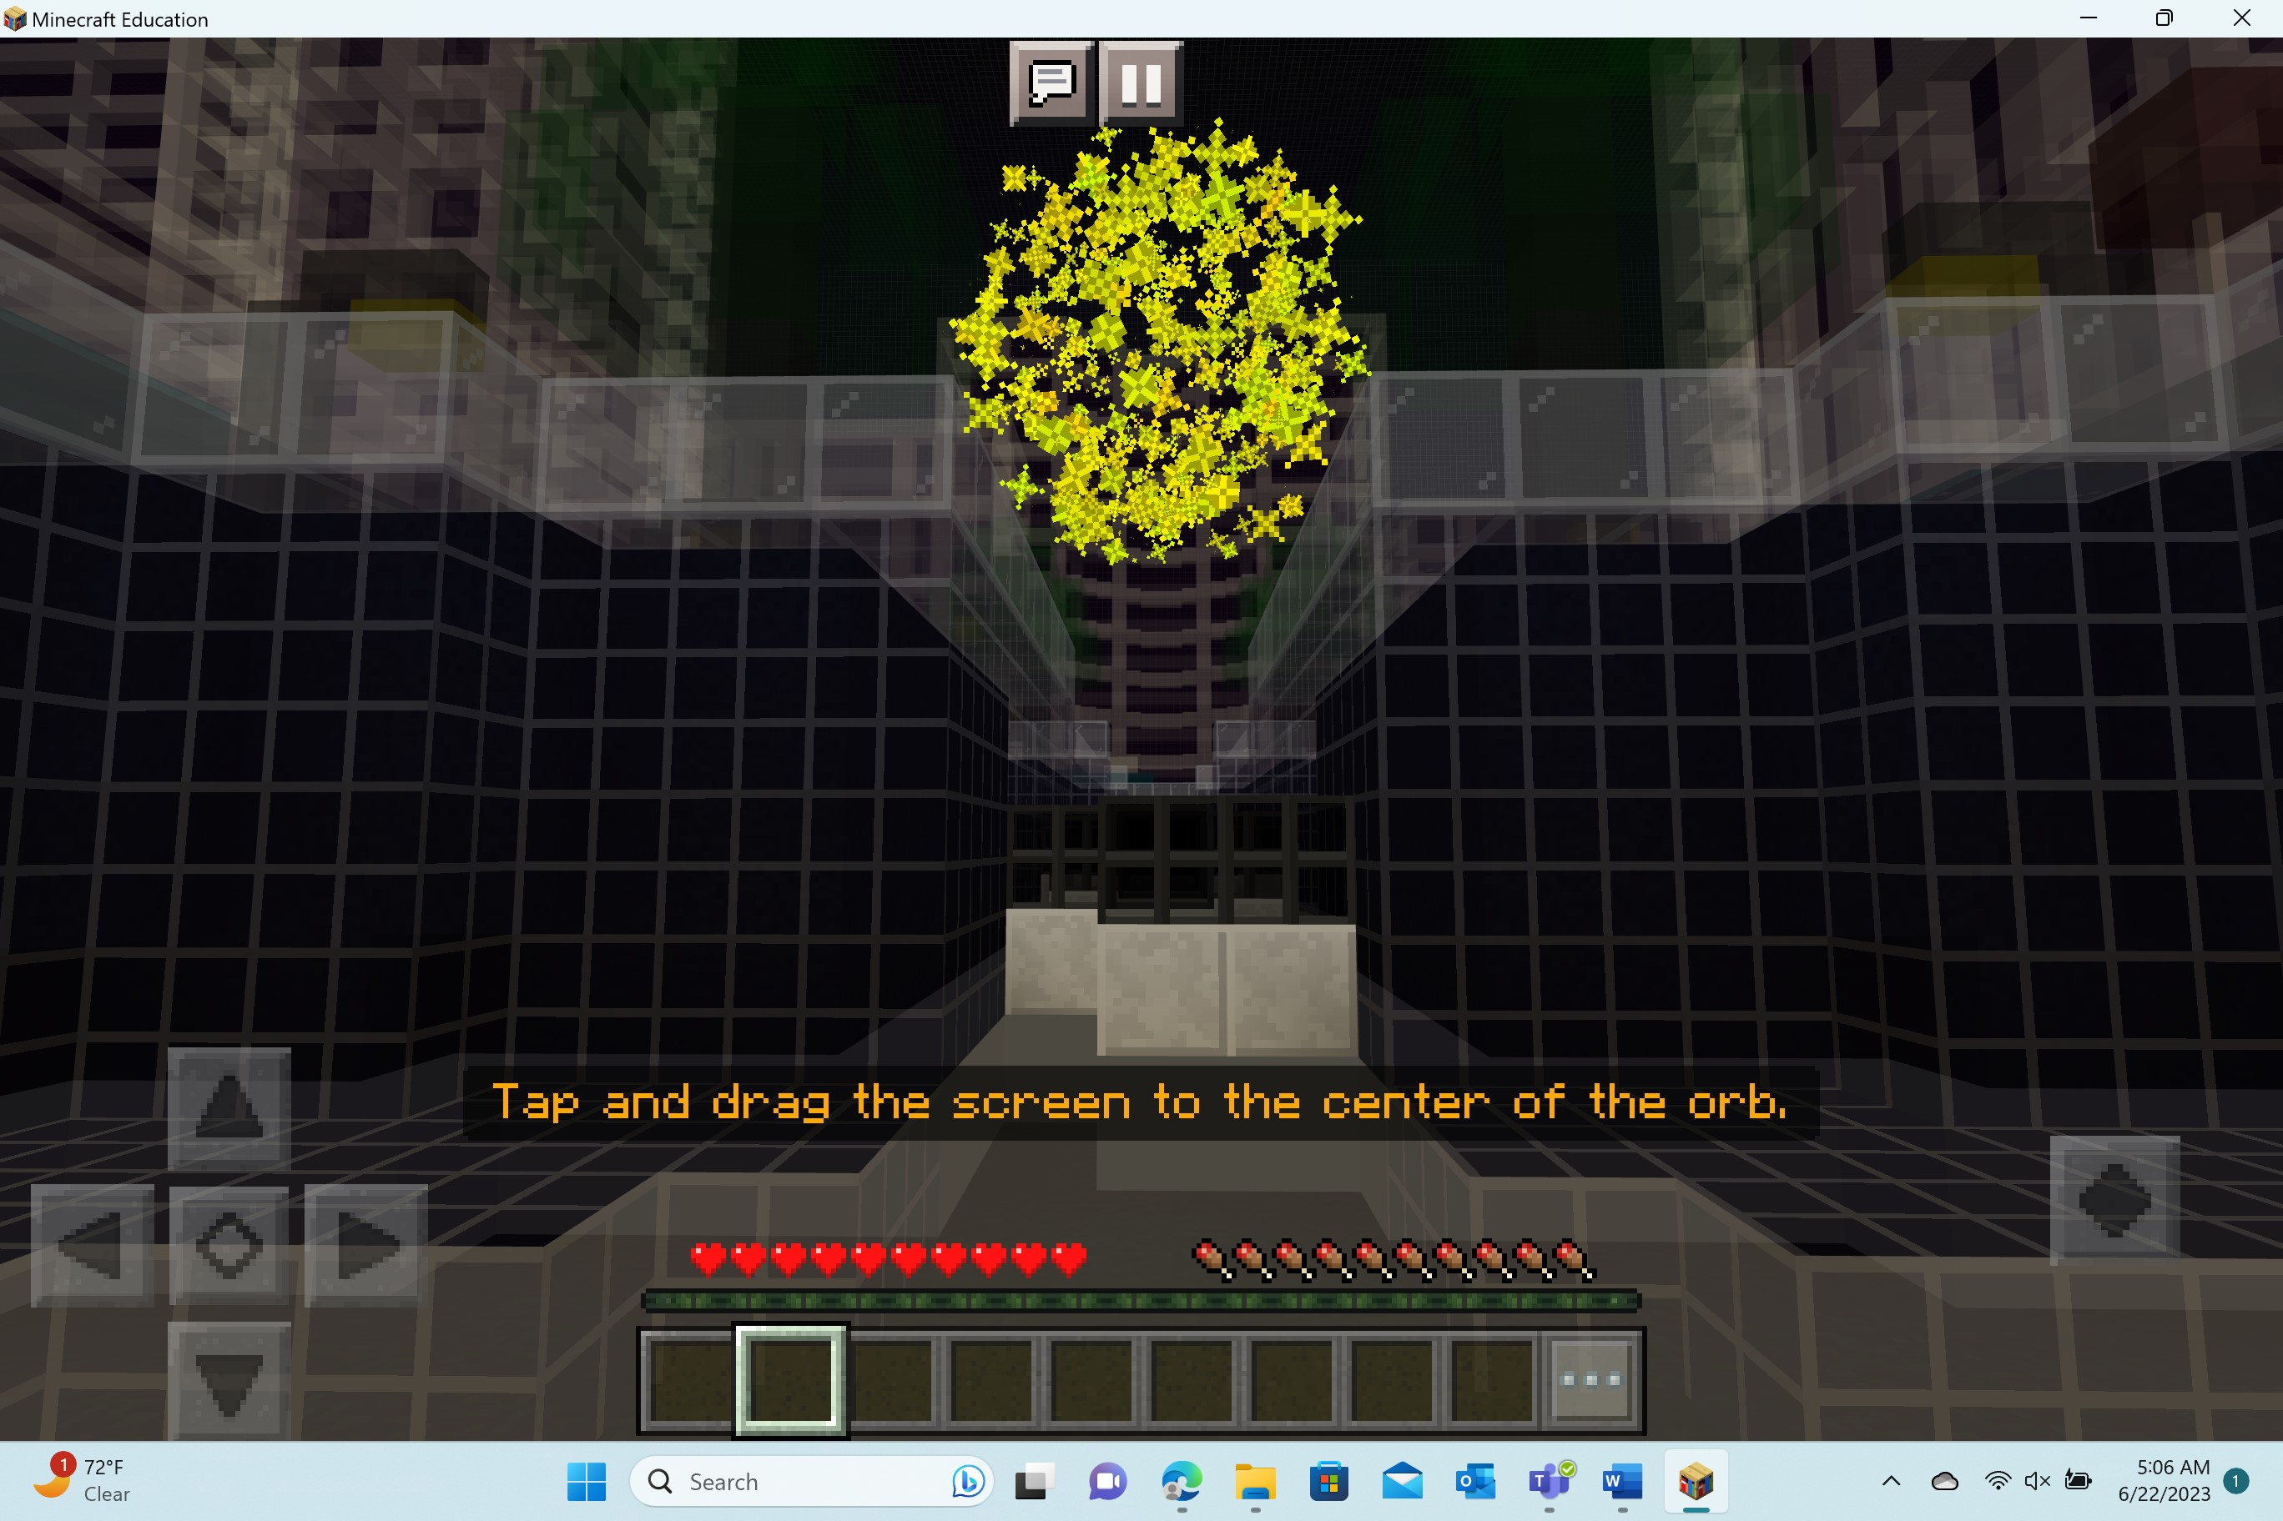  Players will tap and drag the screen to the center of the orb. They will hold until the orb turns white and then disappears. They will look at 9 golden orbs before moving on to the next task.
Task 2: Practice moving

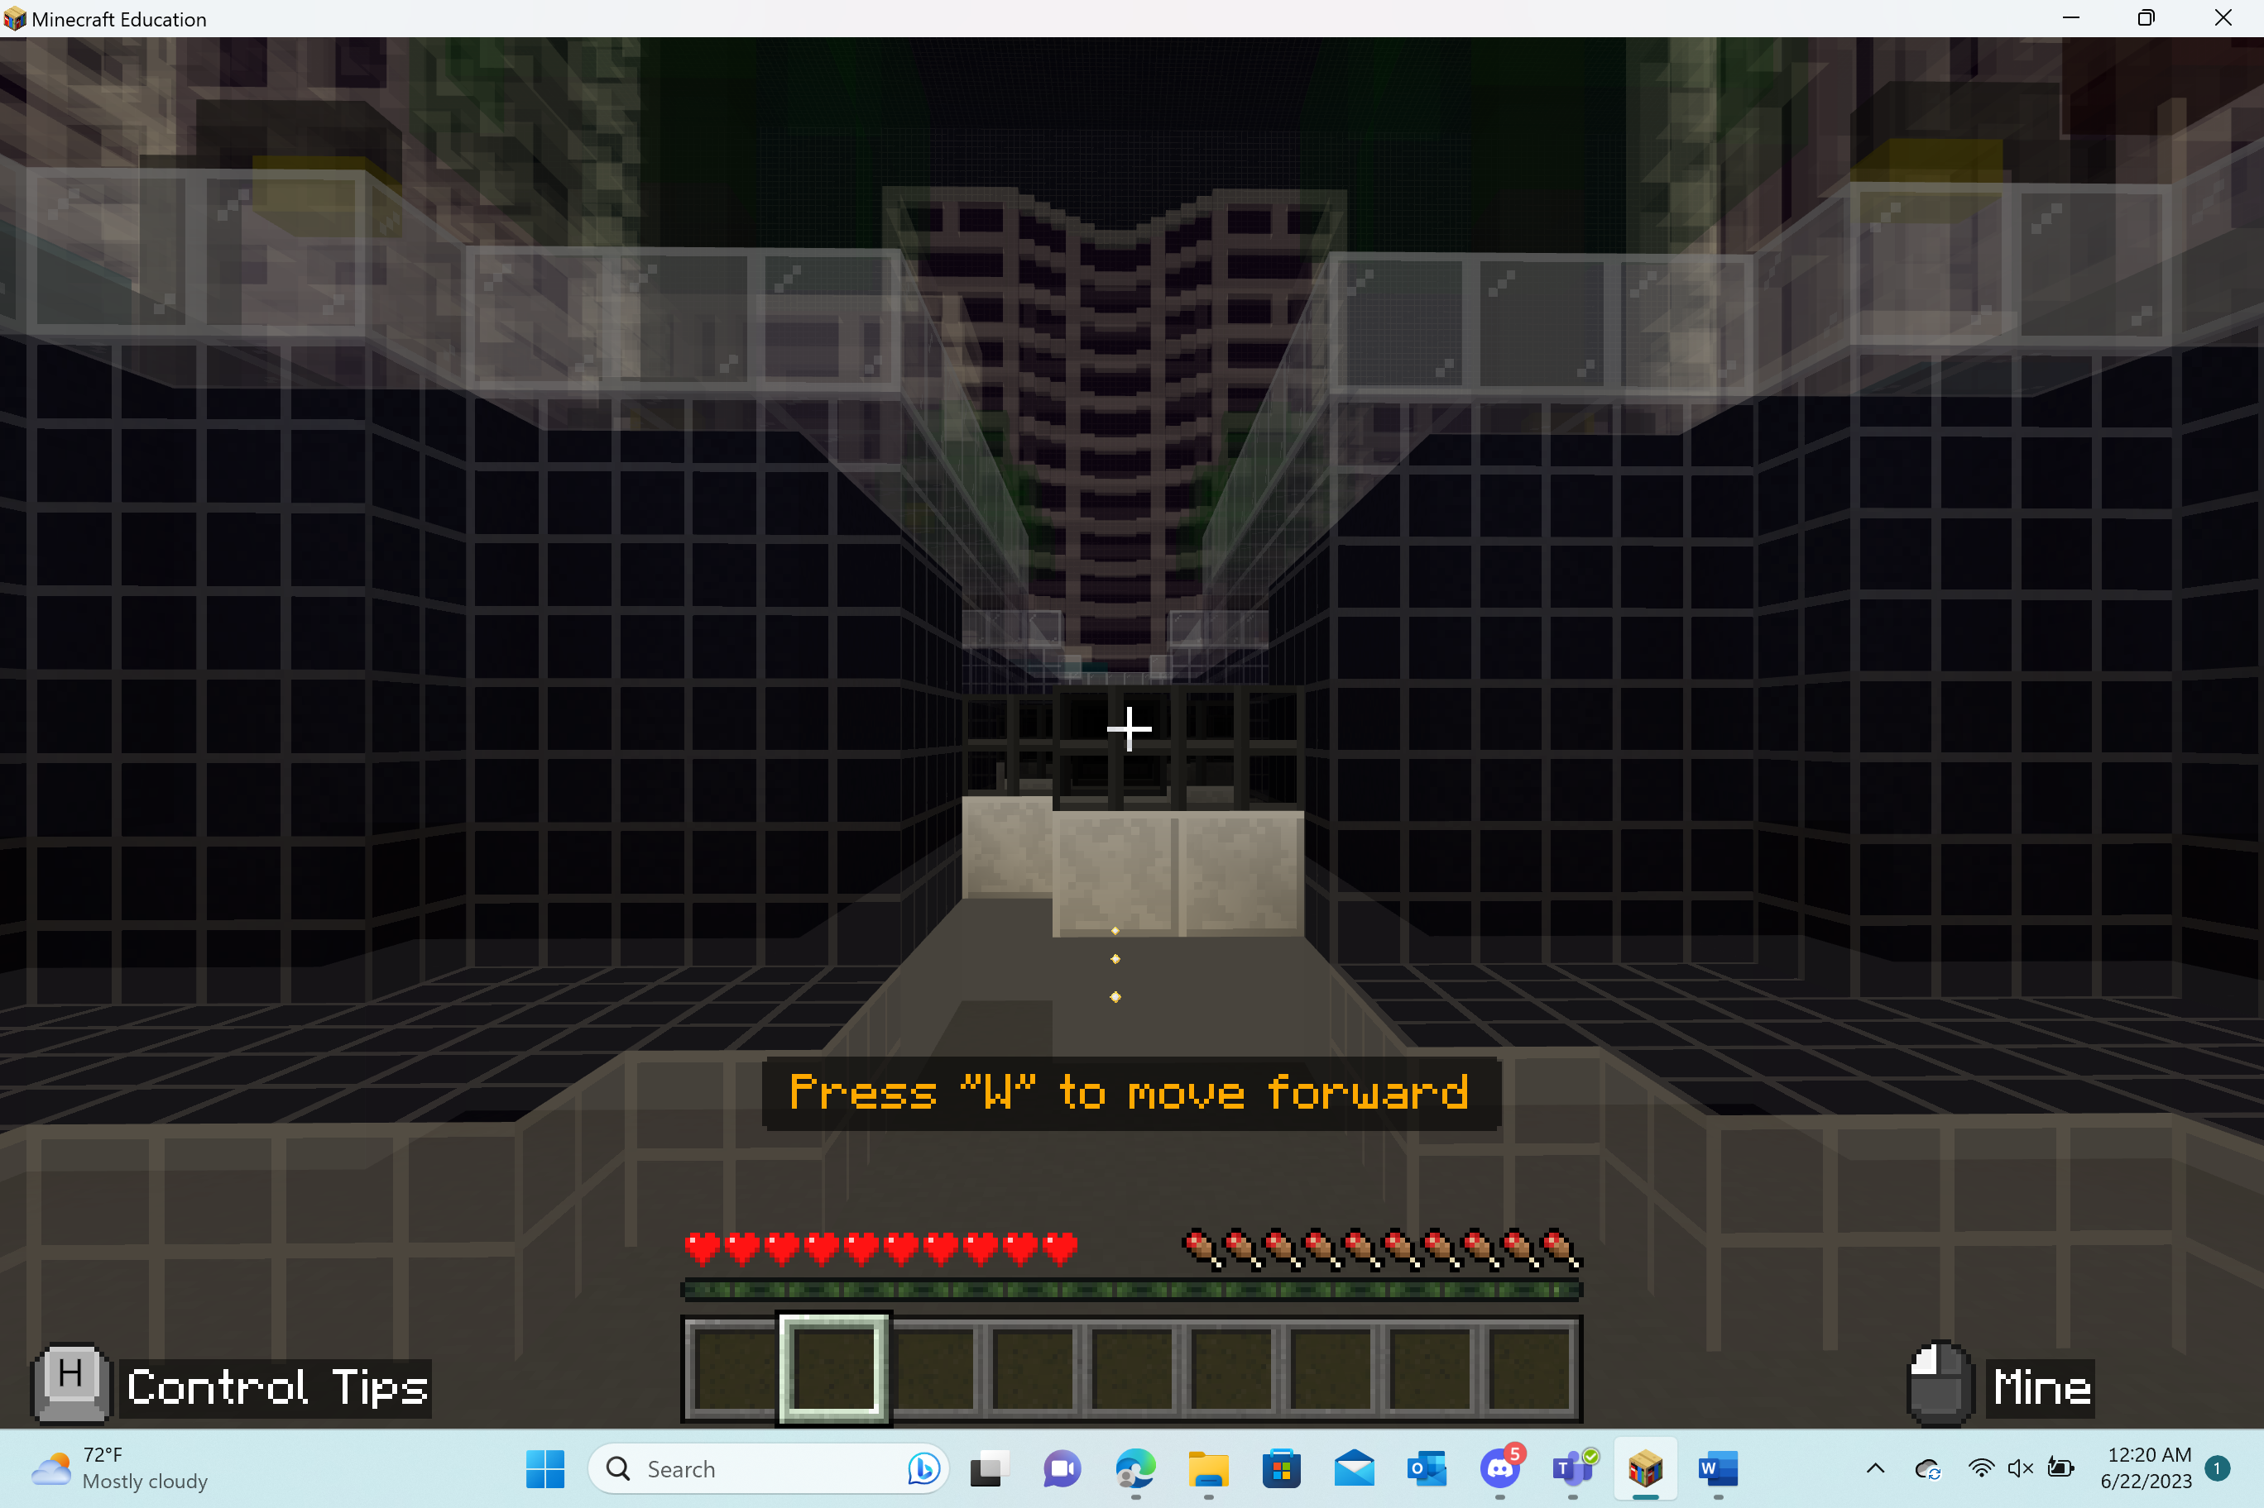  Players will practice moving in the game using the WASD keys.  Press “W” to move forward.  Press “A” to move right.  Press “D” to move left.  (NOTE: Pressing “S” will move the player backwards.) | 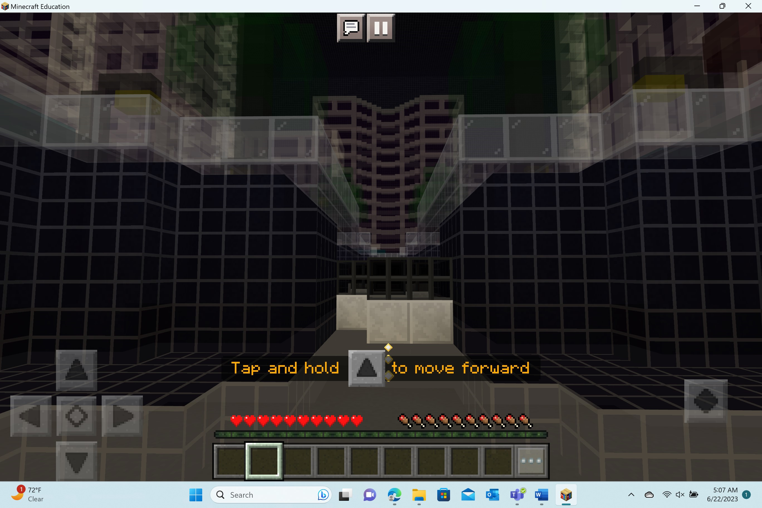  Players will practice moving using the touch controls. The arrows on the touch control (on the bottom left-hand side of the screen) will indicate what direction they can move.
Task 3: Navigate past the wall

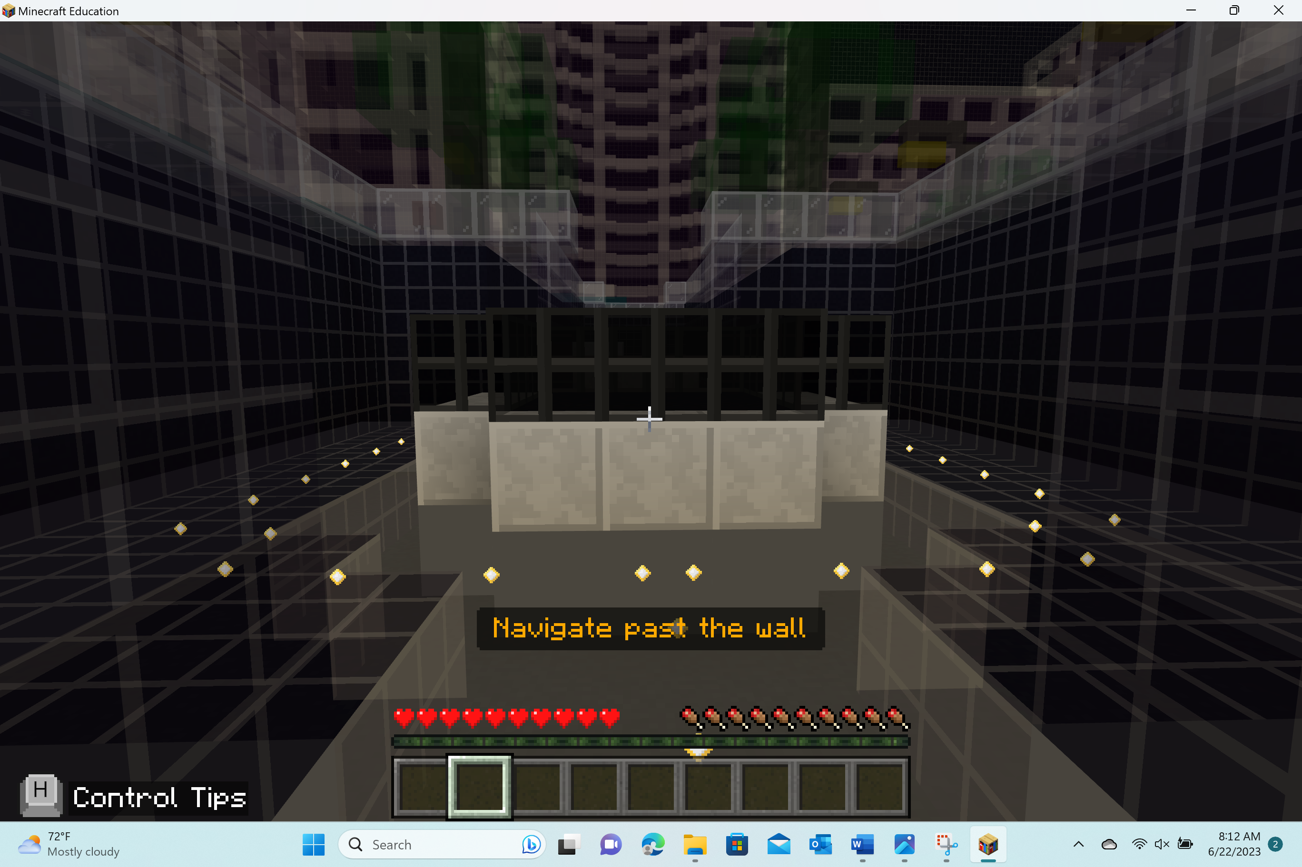  Players need to move past the wall by either moving left or right. | 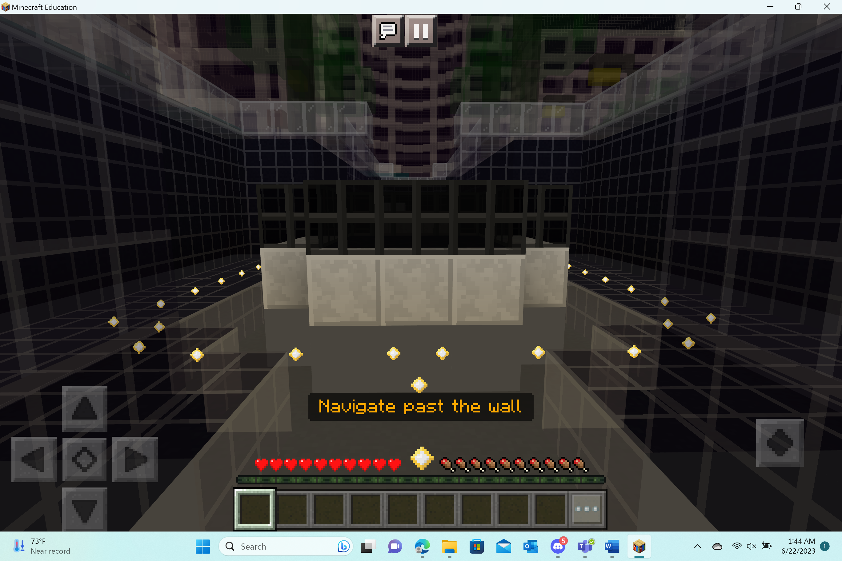  Players need to move past the wall by either moving left or right.
Task 4: Practice jumping

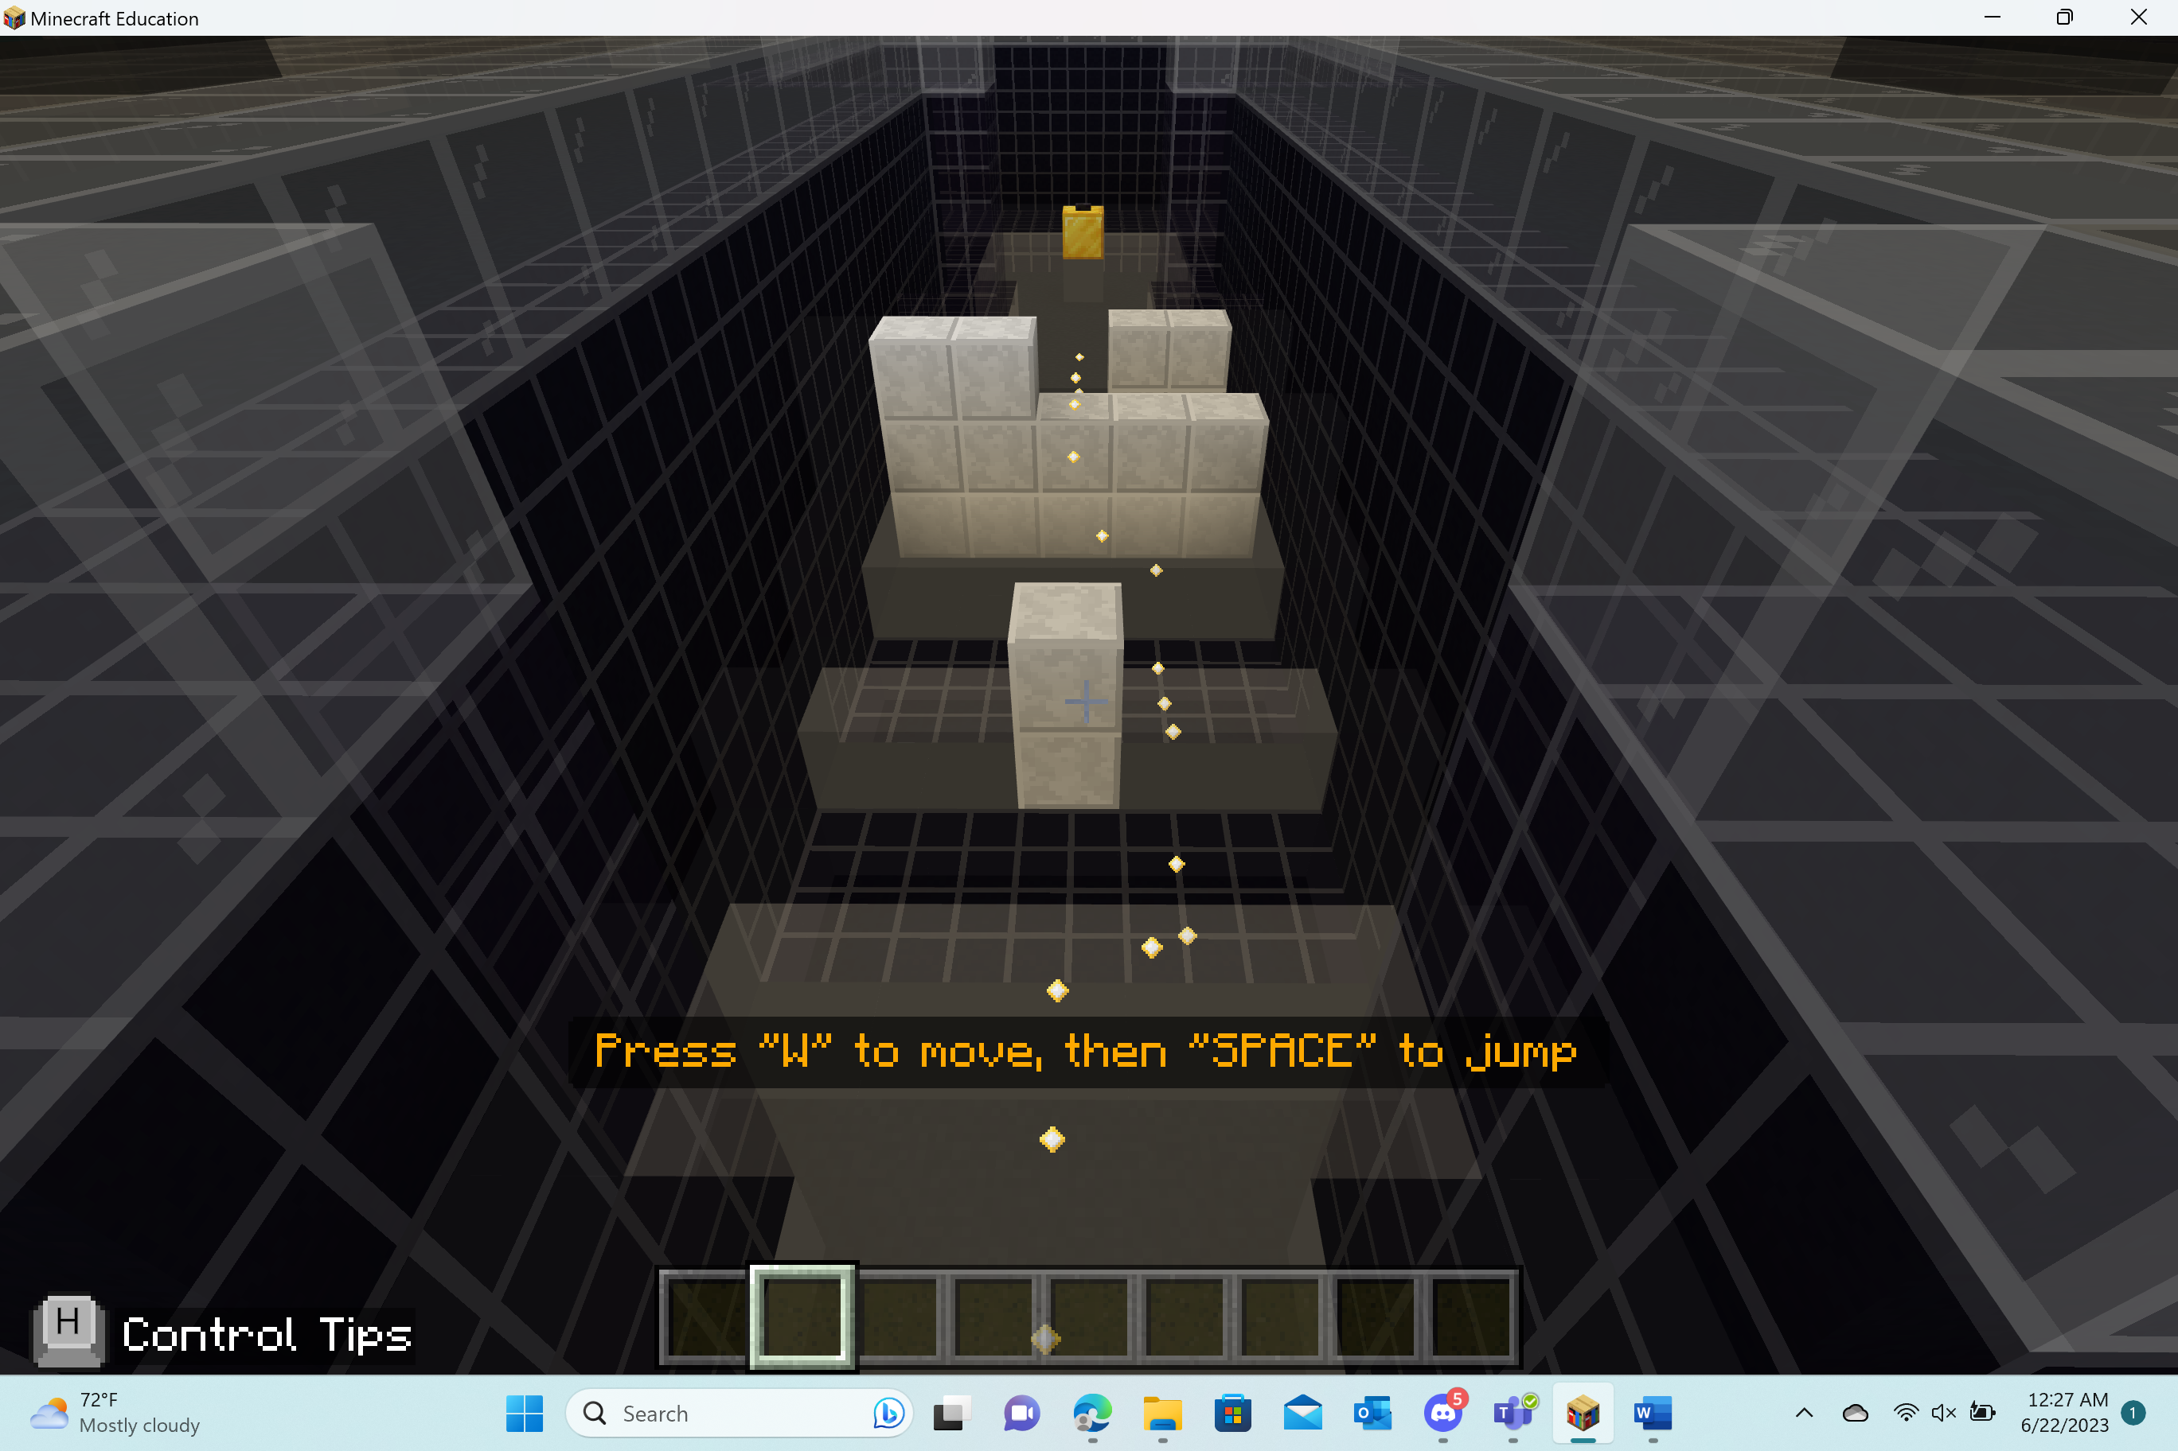  Players should press “W” to move forward and then press “space” to jump. Players should move towards the gold block. | 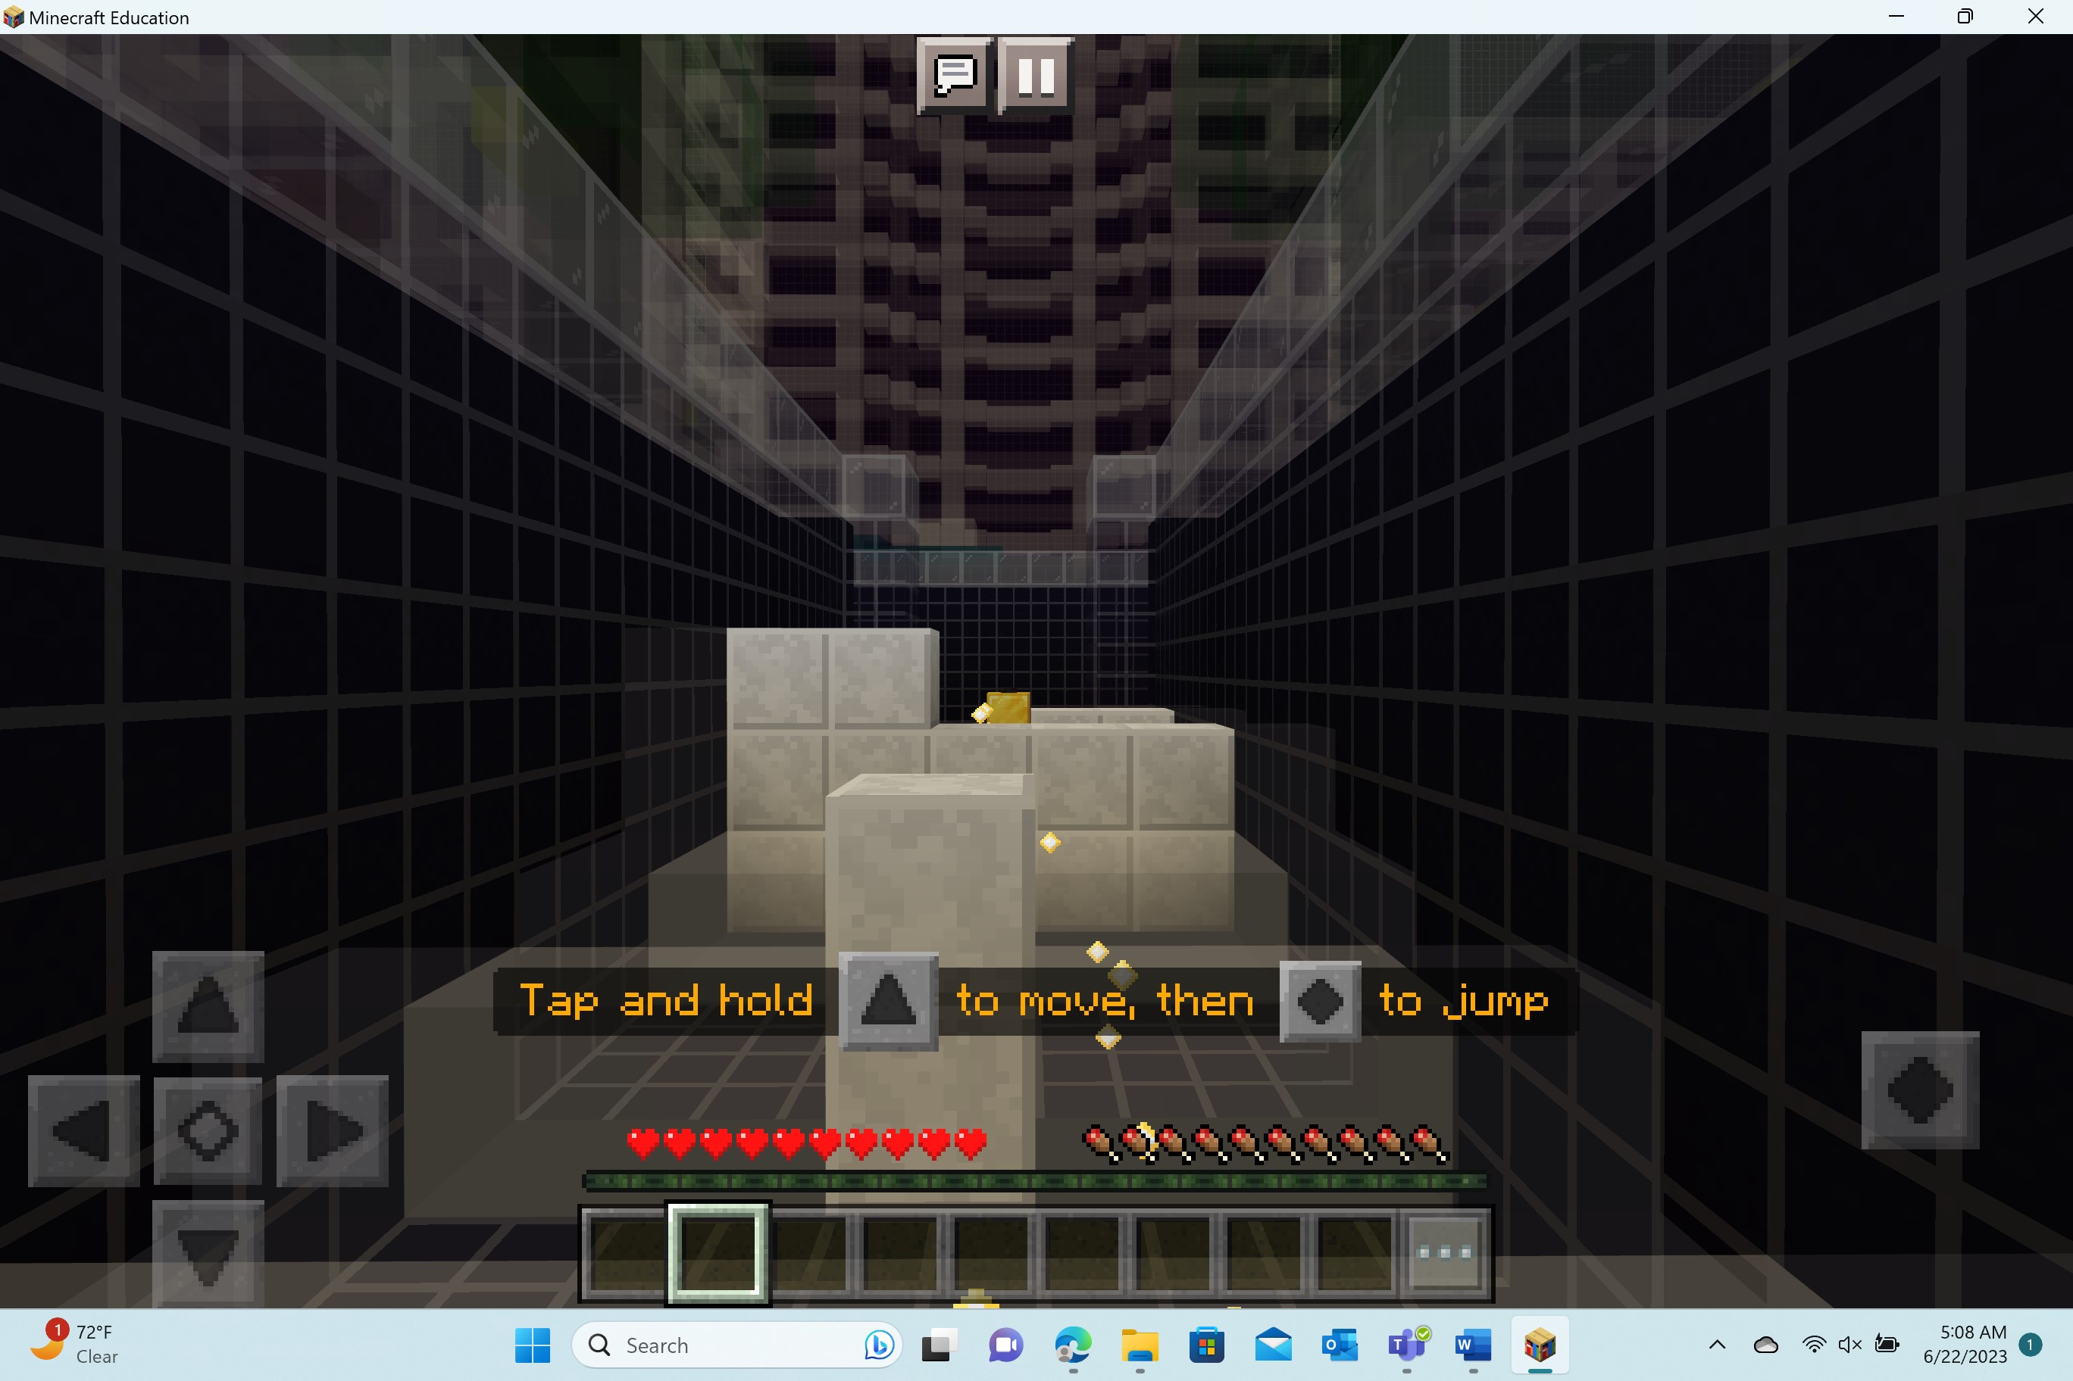  Players need to tap and hold the 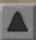(forward command) and then press the  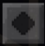 to jump.
Task 5: Press the button

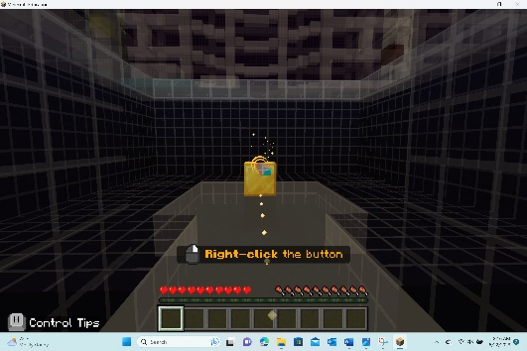  Players will need to press the button on the top of the gold block. They can press the block by right-clicking on the button. | 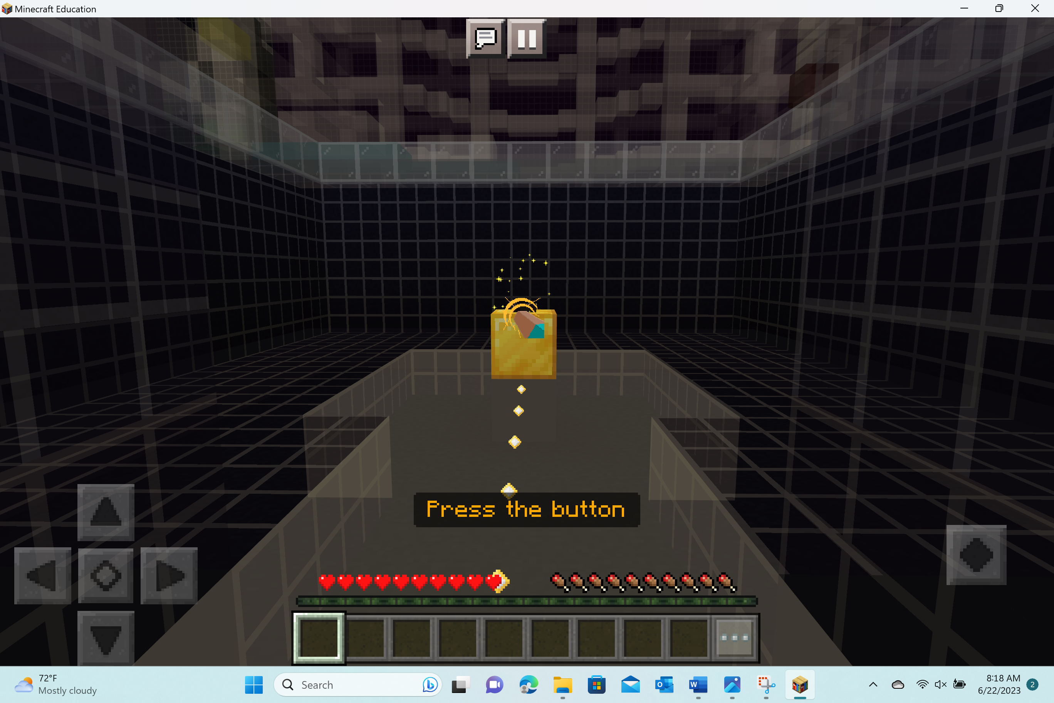  Players need to press the button.

Welcome to Cyber FUNdamentals 1! Let’s get started…

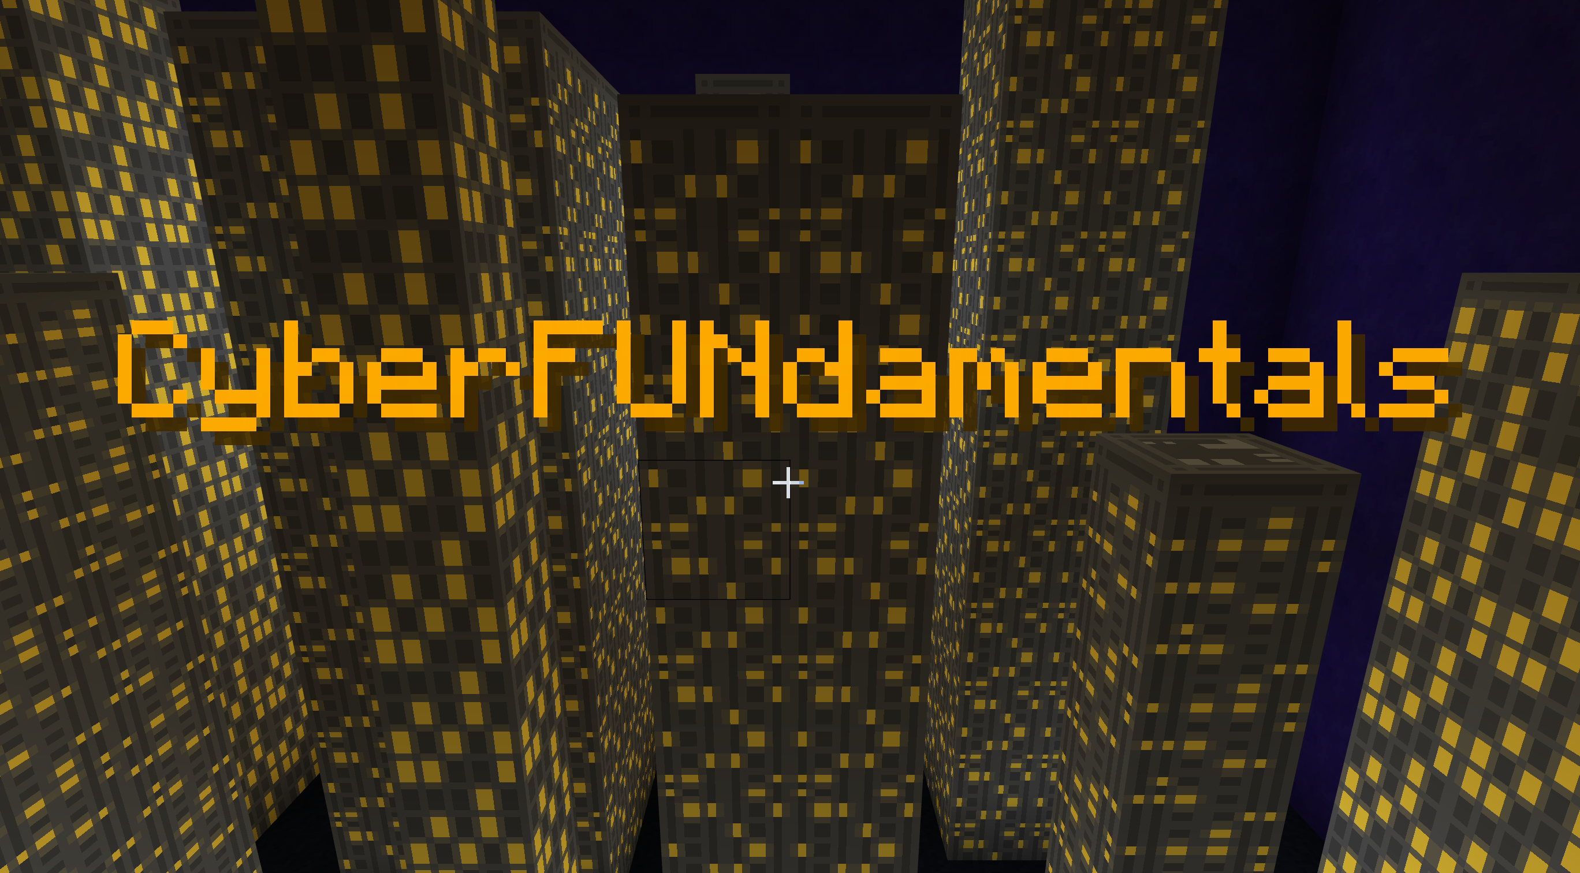

Upon arrival, a dialog box will automatically pop up into the game.

The dialog boxes often provide important information. Players should be encouraged to read all of the information. If you have younger players or readers who need additional support, consider demonstrating and encouraging the use of the Immersive Reader feature.

Immersive Reader is an integrated feature of Minecraft Education. It supports learners in reading or translating in-game text, including the character dialog. When a dialog box is opened, you will see an icon in the bottom right-hand corner of the NPC picture in the dialog box.

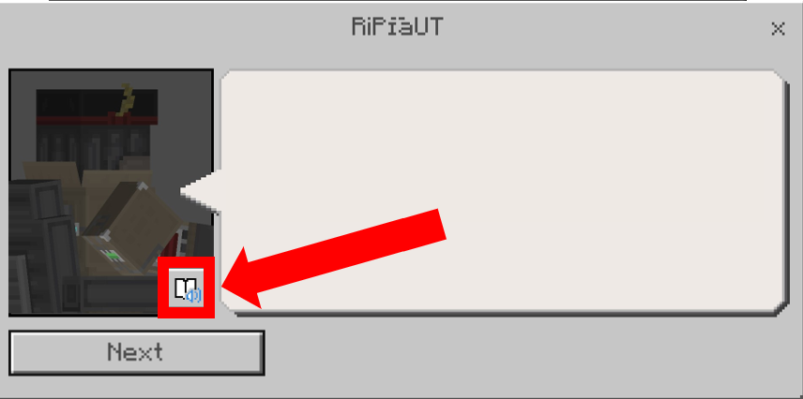

After players have read through the initial dialog box, they are ready to go into their school building. Players will join their teacher and classmates for a cybersecurity adventure!

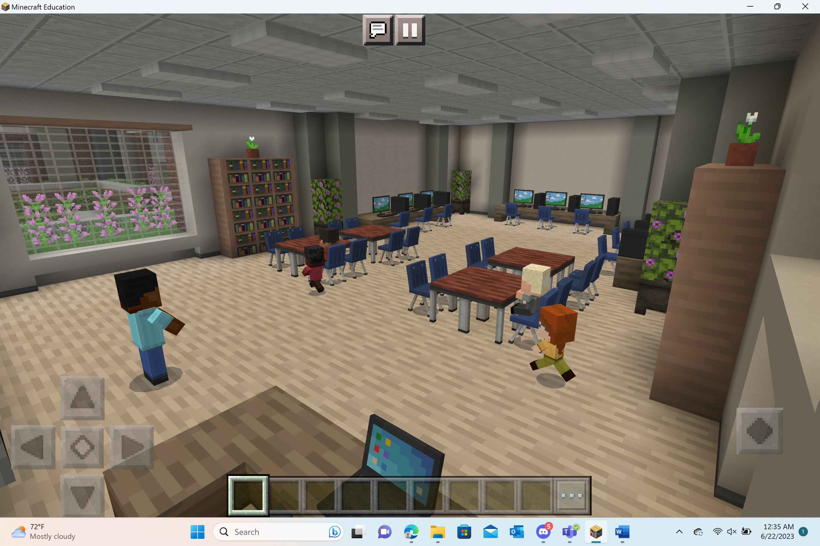

Lesson 1: Network Components
In this activity, players will learn about network connections and how data is sent from computer to computer; network to network.

Activity: Set up the network
Place a computer on each side of the table | Connect the computers using the ethernet cable | Send data between the computers
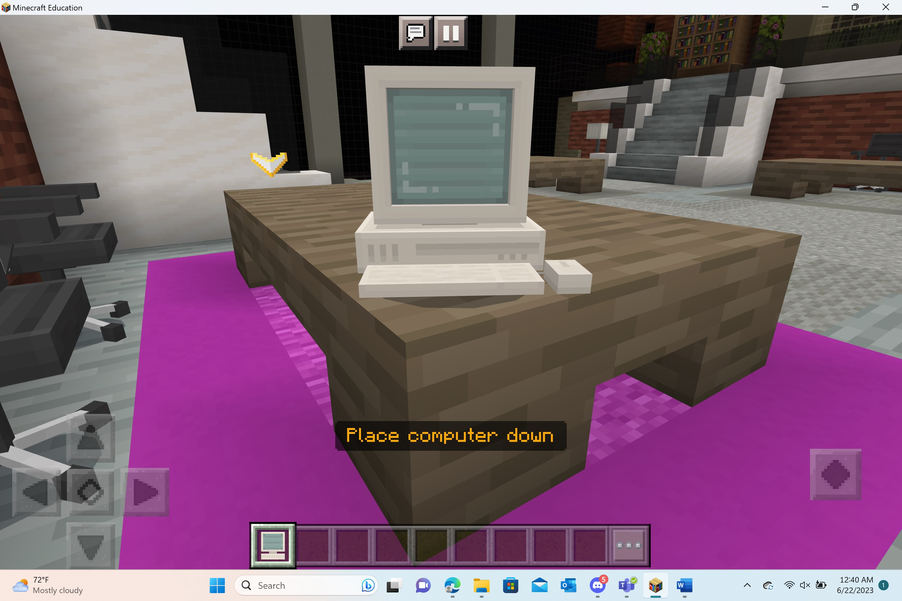 | 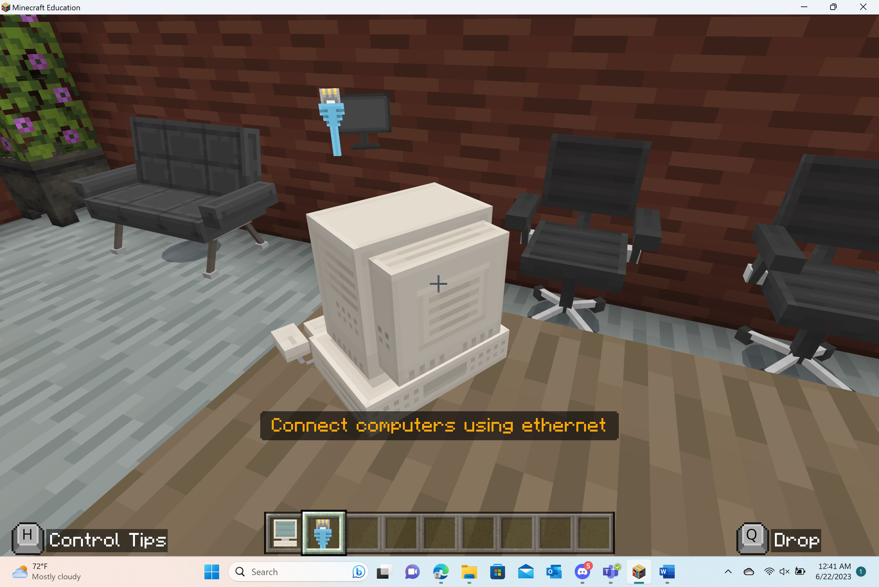 | 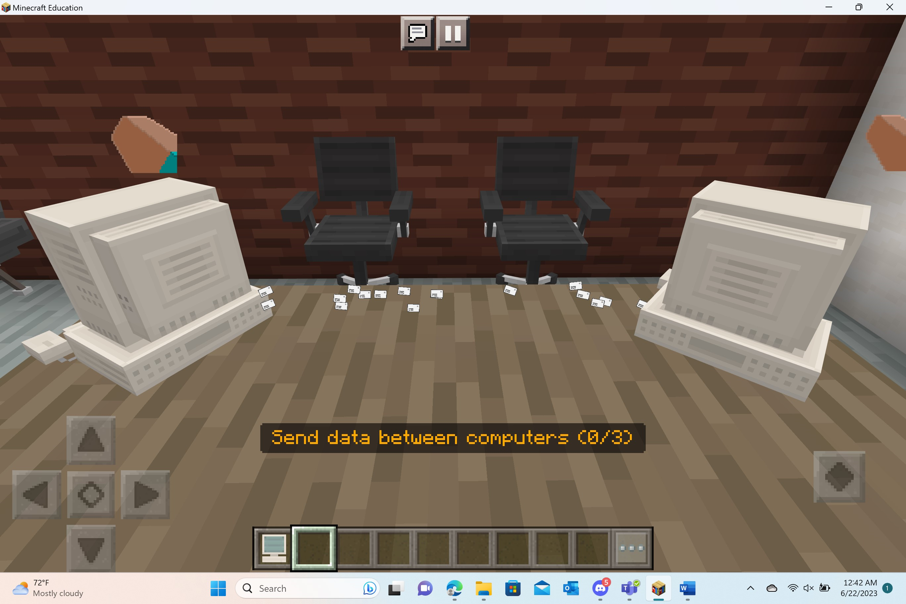
Connect router to the computer | Create two more LANs on the blue and yellow tables | Complete the WAN by connecting routers with the ethernet cable
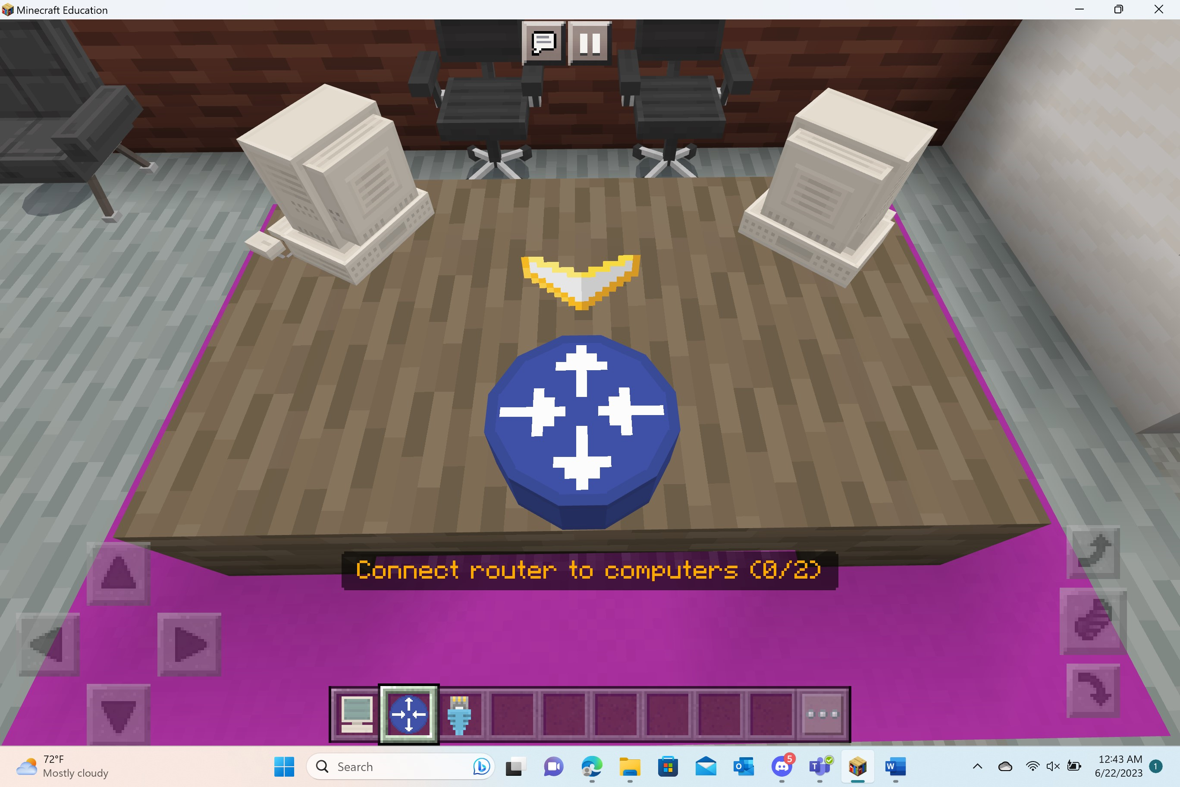 | 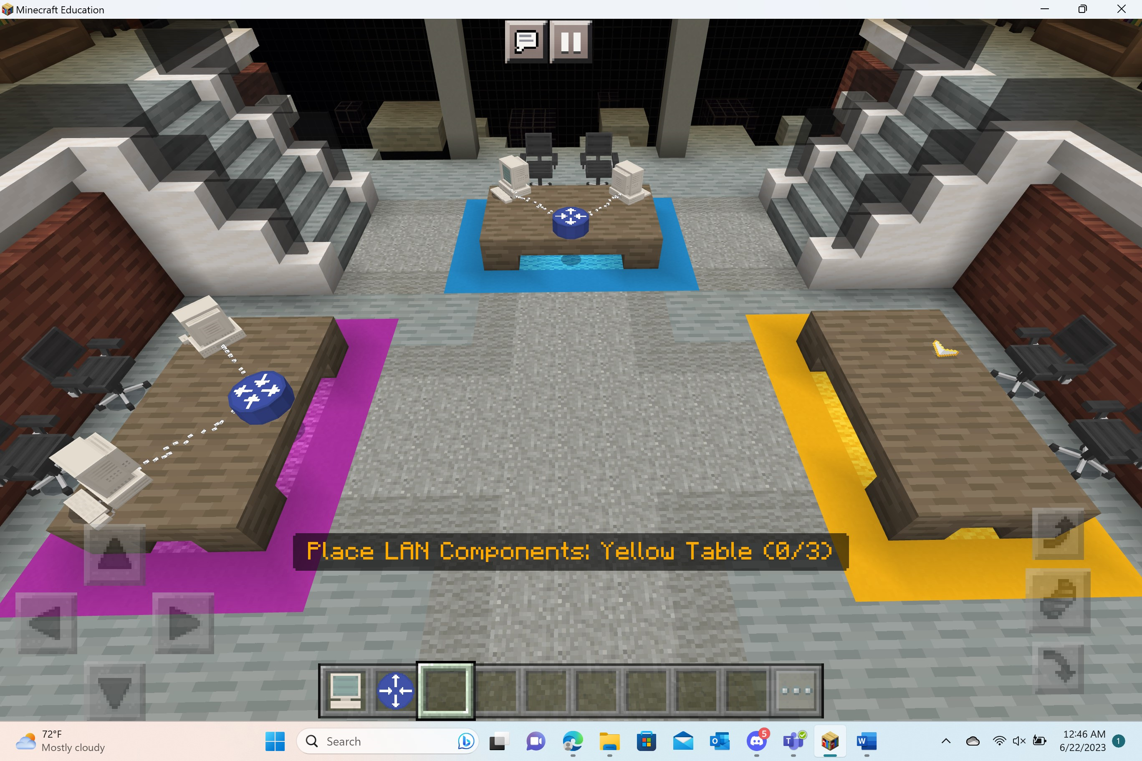 | 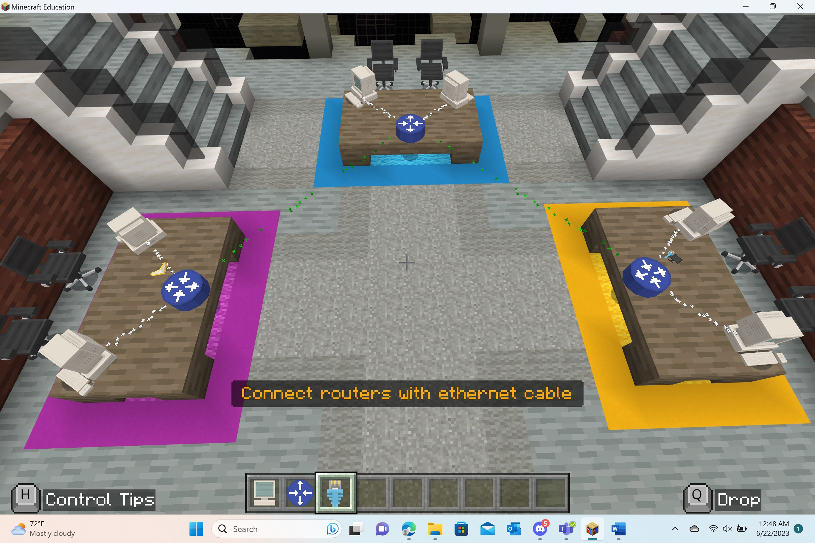

Important Vocabulary:
Packets – A small segment of a larger message; Data sent over computer networks, such as the Internet, is divided into packets.
Local Area Network (LAN) - A private network contained within a small single geographic area
Routers – A networking device that forwards data packets between computer networks
Wide Area Network (WAN) - A network spread across a large geographic area

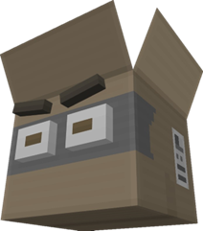
Activity: Encrypt the data
We have a problem…
The Packet Thief is trying to siphon the data!

Players will need to find the 5 computers in the room. They will need to interact with the computers in order to encrypt the data.
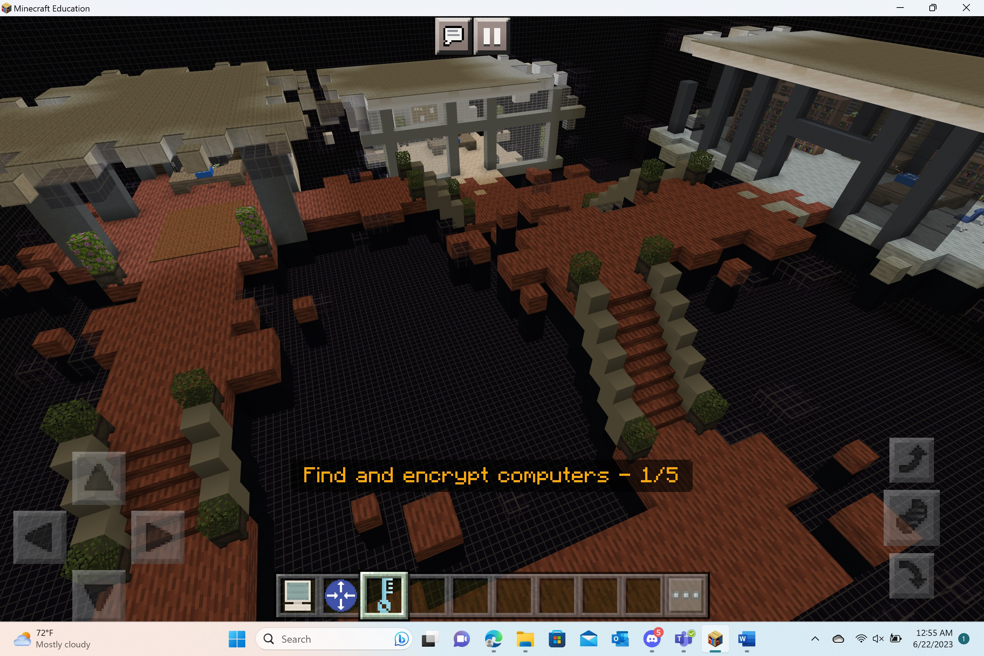
Important Vocabulary:
Switch – Devices that connect multiple computers on a network and enable them to communicate with each other
Encryption - The reversible process of obscuring a message in order to prevent unauthorized access

Formative Assessment
Welcome to the focus room!

Players will have the opportunity to reflect and think about what they just learned in Lesson 1. They will receive a book & quill in their hotbar. Upon opening the book, they will find the following prompts:

- What components make up a local-area network (LAN)?
- How are a local area-network (LAN) and wide-area network (WAN) different from one another?
- Draw and label a diagram of how information travels through a network.

Players should capture their answers by turning to a new page in the book and typing directly into the blank page.
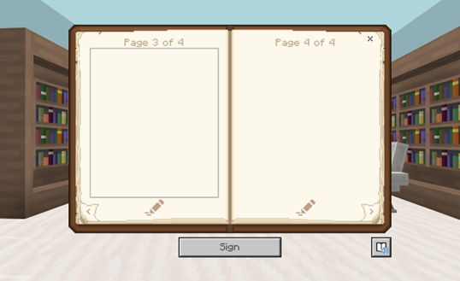

Lesson 2: Password Protection
In this lesson, players will learn how to create complex passwords, their role in network security, and other layered security practices (such as 2FA) to keep unauthorized users from accessing their networks.

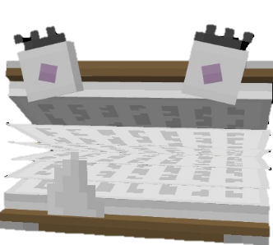
Activity: Complex Passwords
Dictionary Attacker is trying to use brute-force to access the network!
Players will go through three iterations of password creation. They will learn how to use letters, numbers, and characters to strengthen the complexity of their passwords.
7 Letters | 8 Total – Letters & Numbers | 9 Total – Letters, Numbers, and Special Characters
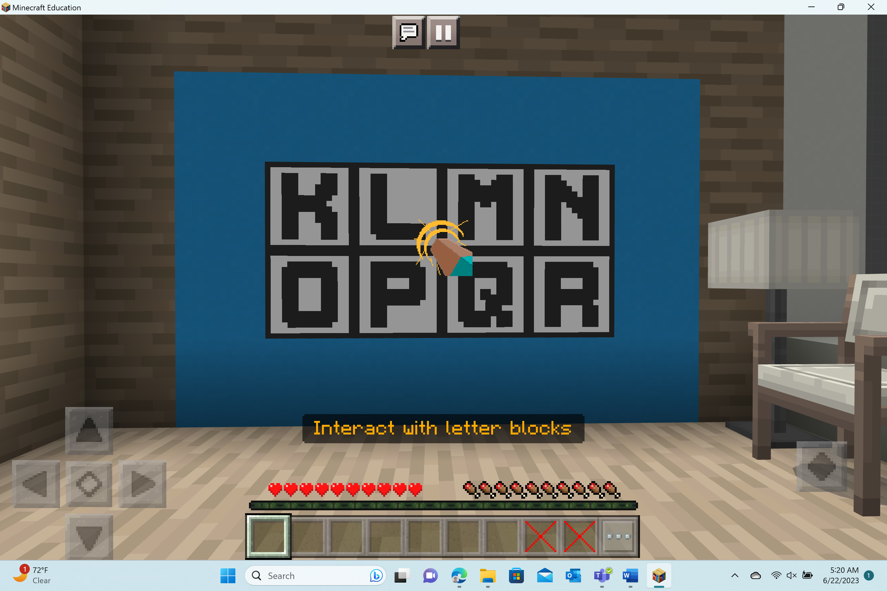 | 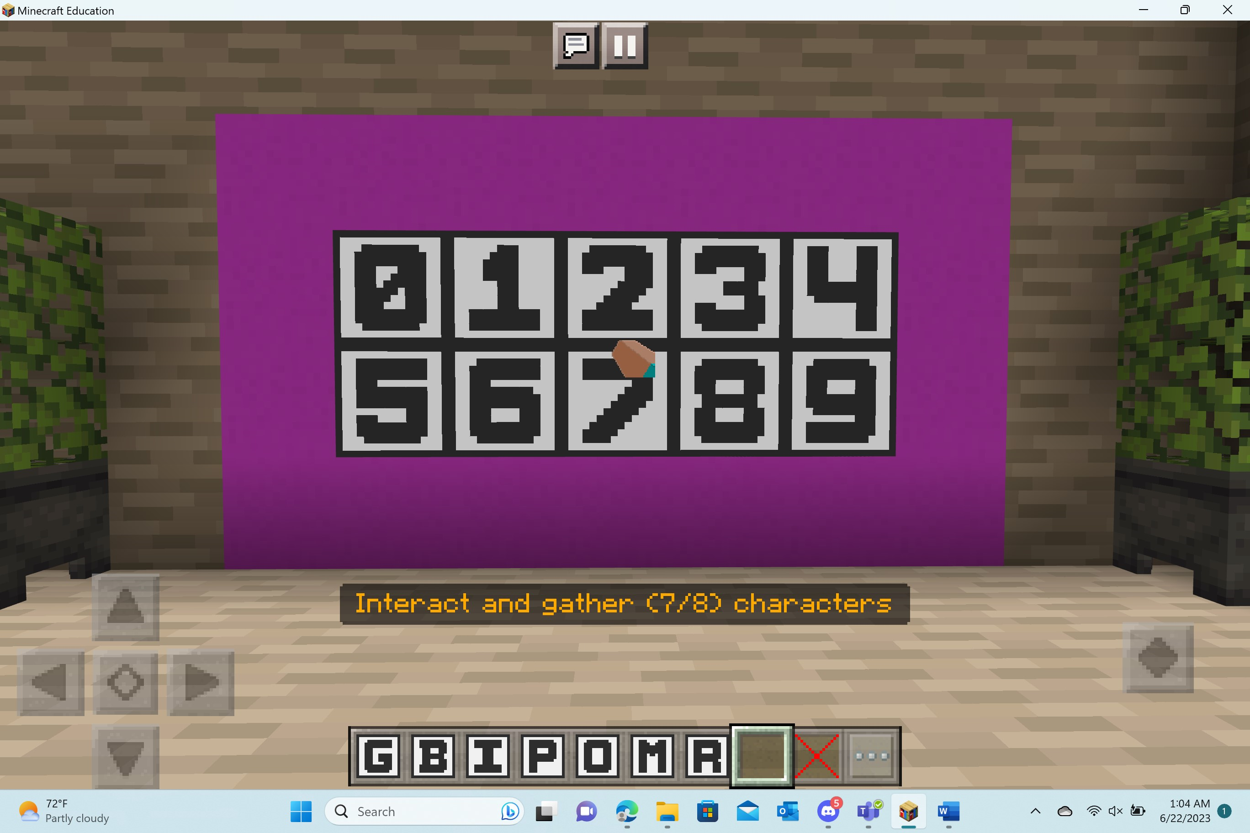 | 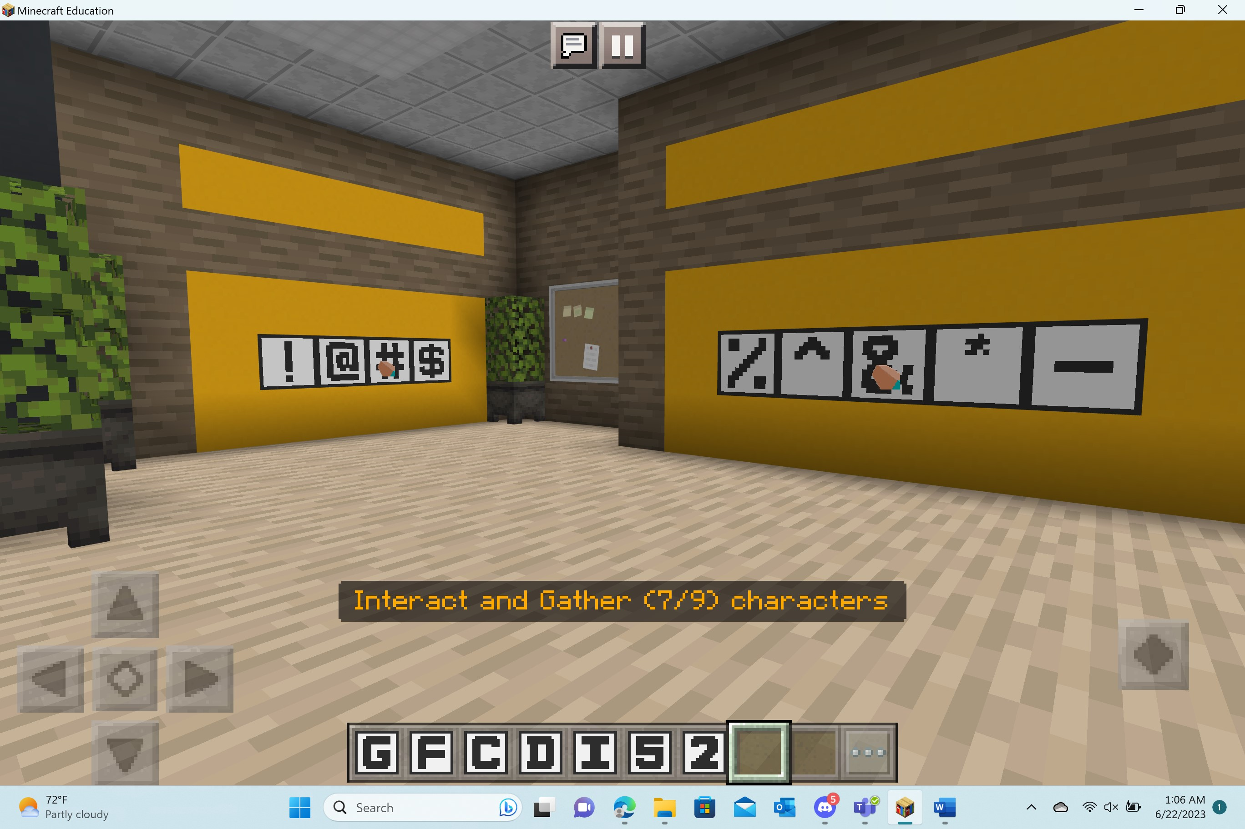

Important Vocabulary:
Password Entropy – measurement of how strong or unpredictable a password
Two-Factor Authentication – method of verifying the identity of an individual bt requiring two types of credentials for authentication
Network Firewall - A network device which filters authorized and unauthorized network traffic based on certain criteria
Layered Strategies – security approach that provides multiple types of security controls to protect the network

Formative Assessment
Welcome to the focus room!

Players will have the opportunity to reflect and think about what they just learned in Lesson 2. They will receive a book & quill in their hotbar. Upon opening the book, they will find the following prompts:

- How can you create a complex password?
- Why are complex passwords important in cybersecurity?
- Name one other way to keep a network safe.

Players should capture their answers by turning to a new page in the book and typing directly into the blank page.

Lesson 3: Malware
In this lesson, players will learn what malware is, how to identify it, and what steps they can take to keep themselves safe from it.

Activity: Quarantine the malware
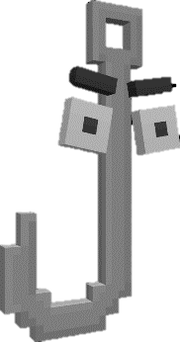
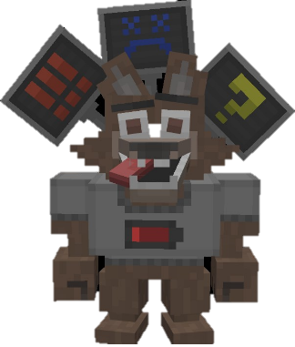
The teachers in the school have been exposed to malware!
Adwarewolf and Phisher have been trying to infect the network with malware. Players must go into two different websites to quarantine the malware.

Website 1: The Store  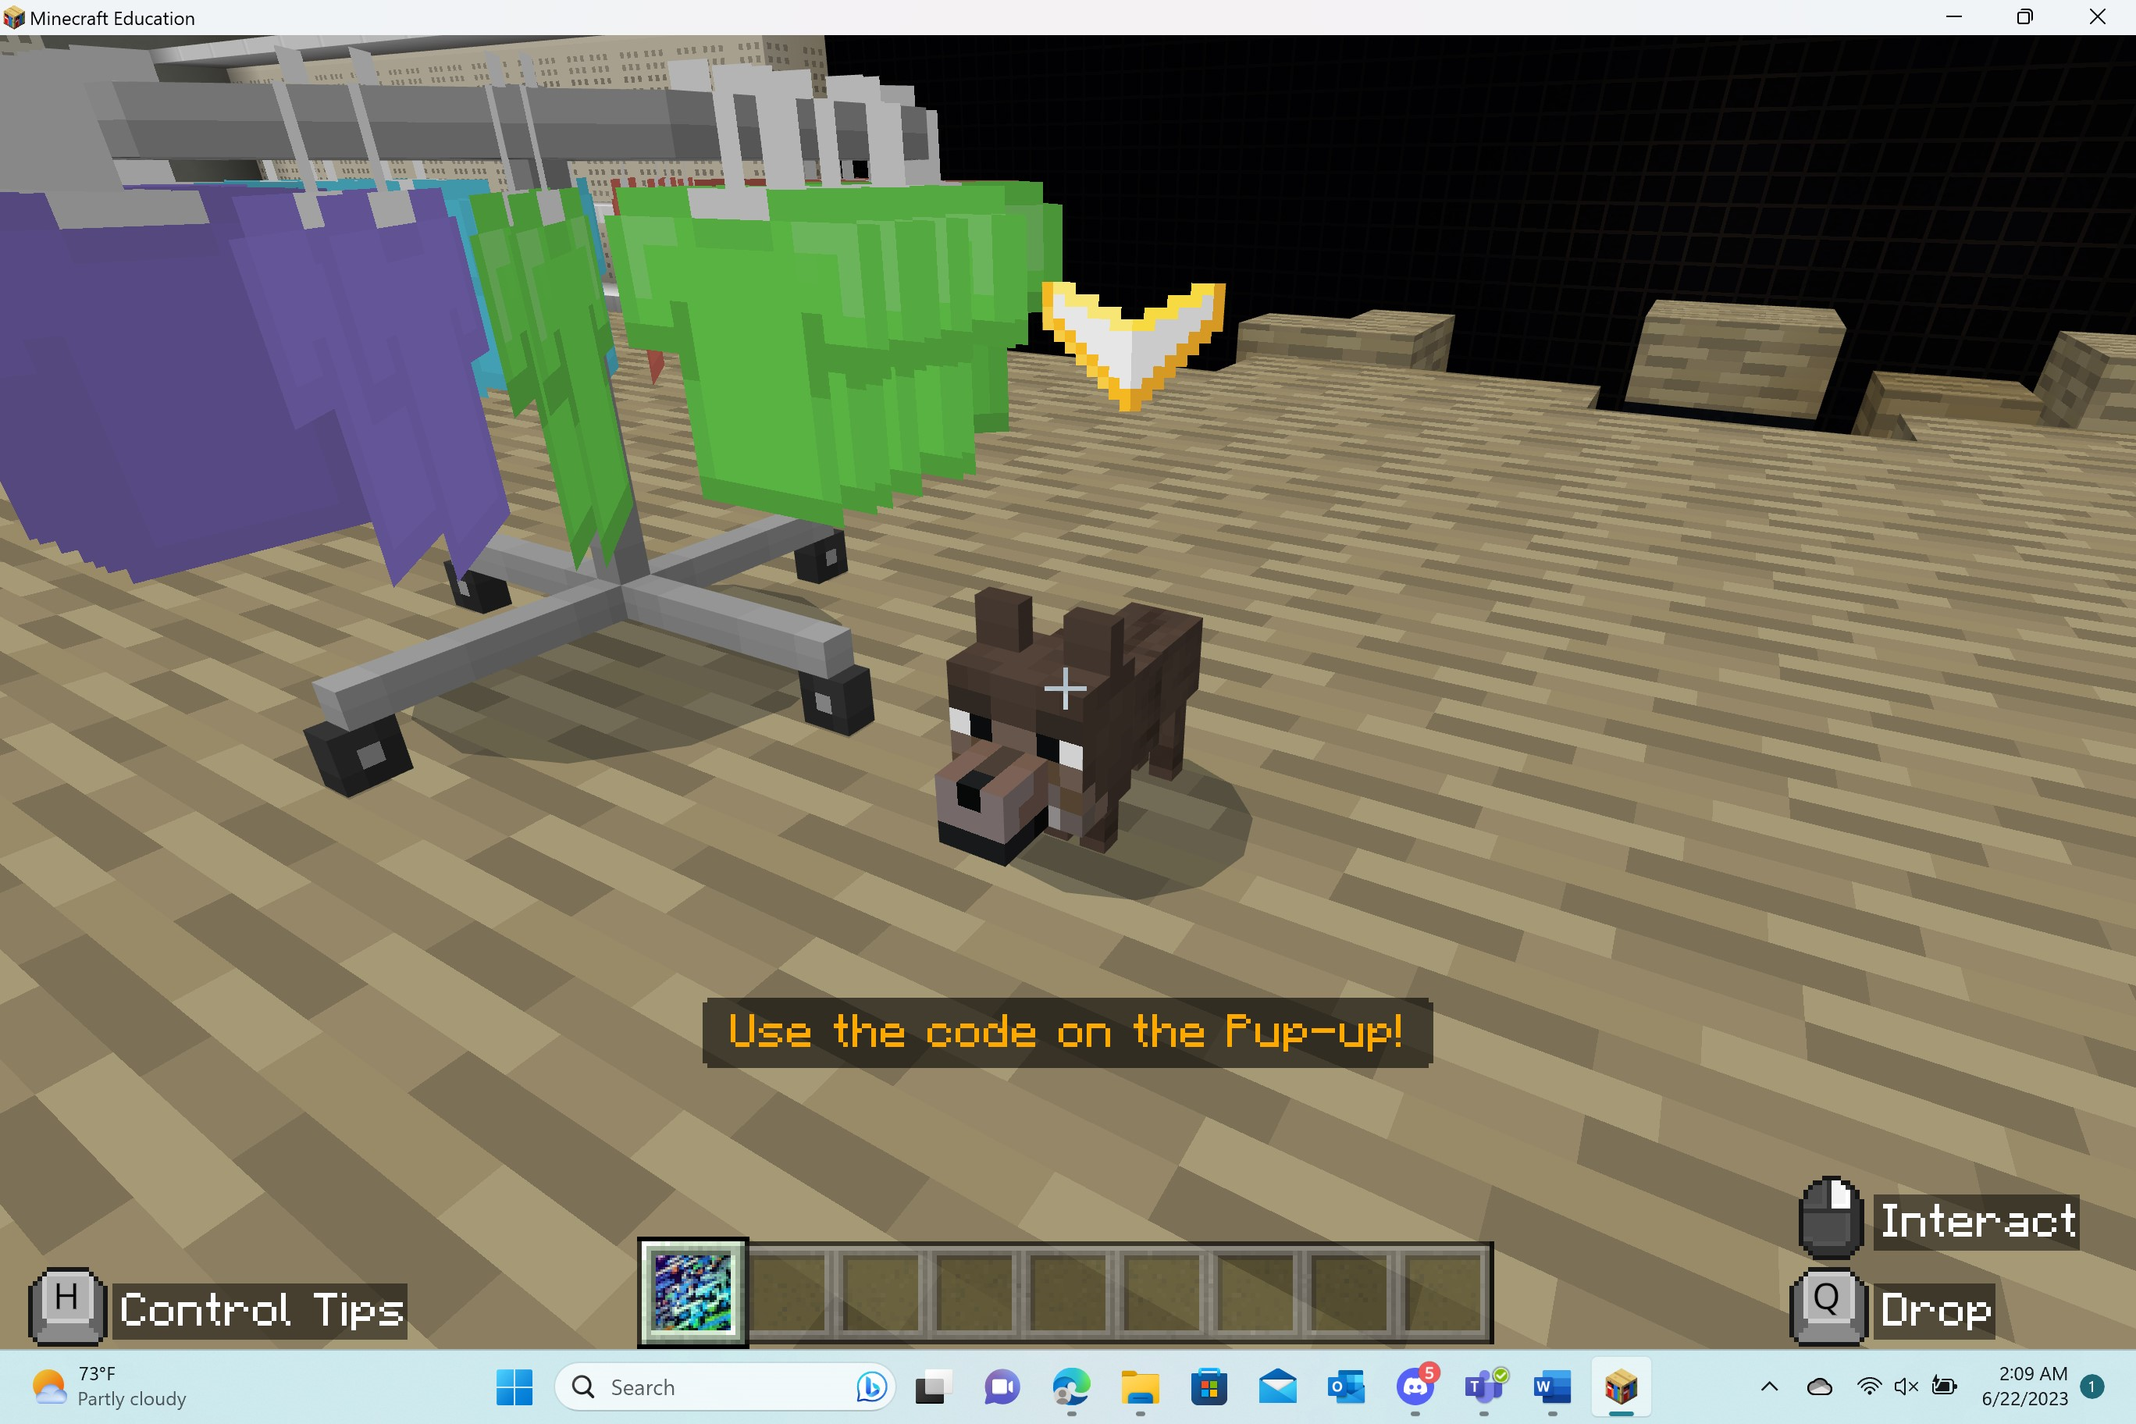 | Website 2: Village Social  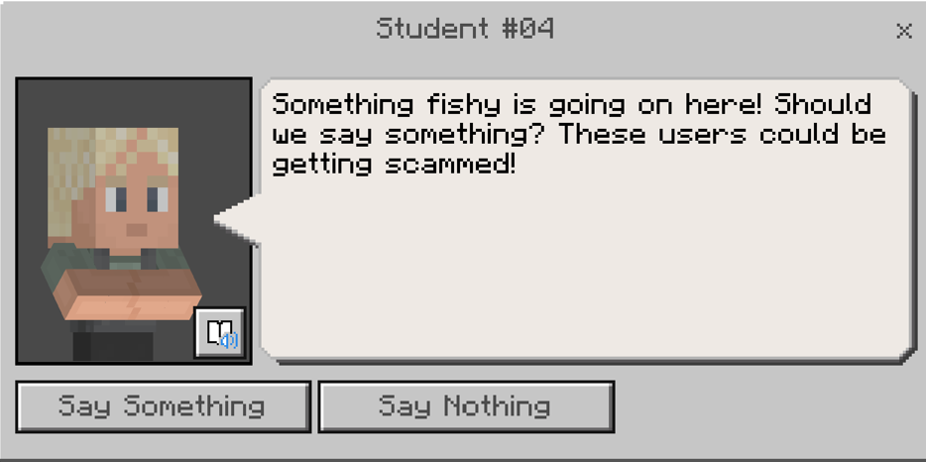
Players must find apples, shirts, and brooms. These specific items have been targeted. Players should use the code on the “Pup-up” to quarantine the malware. | Players must speak to the different users on the social media site. They should speak up to help save the users from being scammed.

Important Vocabulary
Malware – (short for malicious software) software designed specifically to disrupt, damage, or gain unauthorized access to computers, servers, clients, or networks
Phishing – online scam targeting individuals in order to gain access to sensitive information
Personal Information – information that can identify an individual

Activity: The boss battle
Players will need to protect the network by battling against both Adwarewolf and Phisher. In order to quarantine these malware bosses, player will need to activate the 3 cybersecurity systems throughout the room and then quarantine the malware!
Activate the systems | Banish the malware
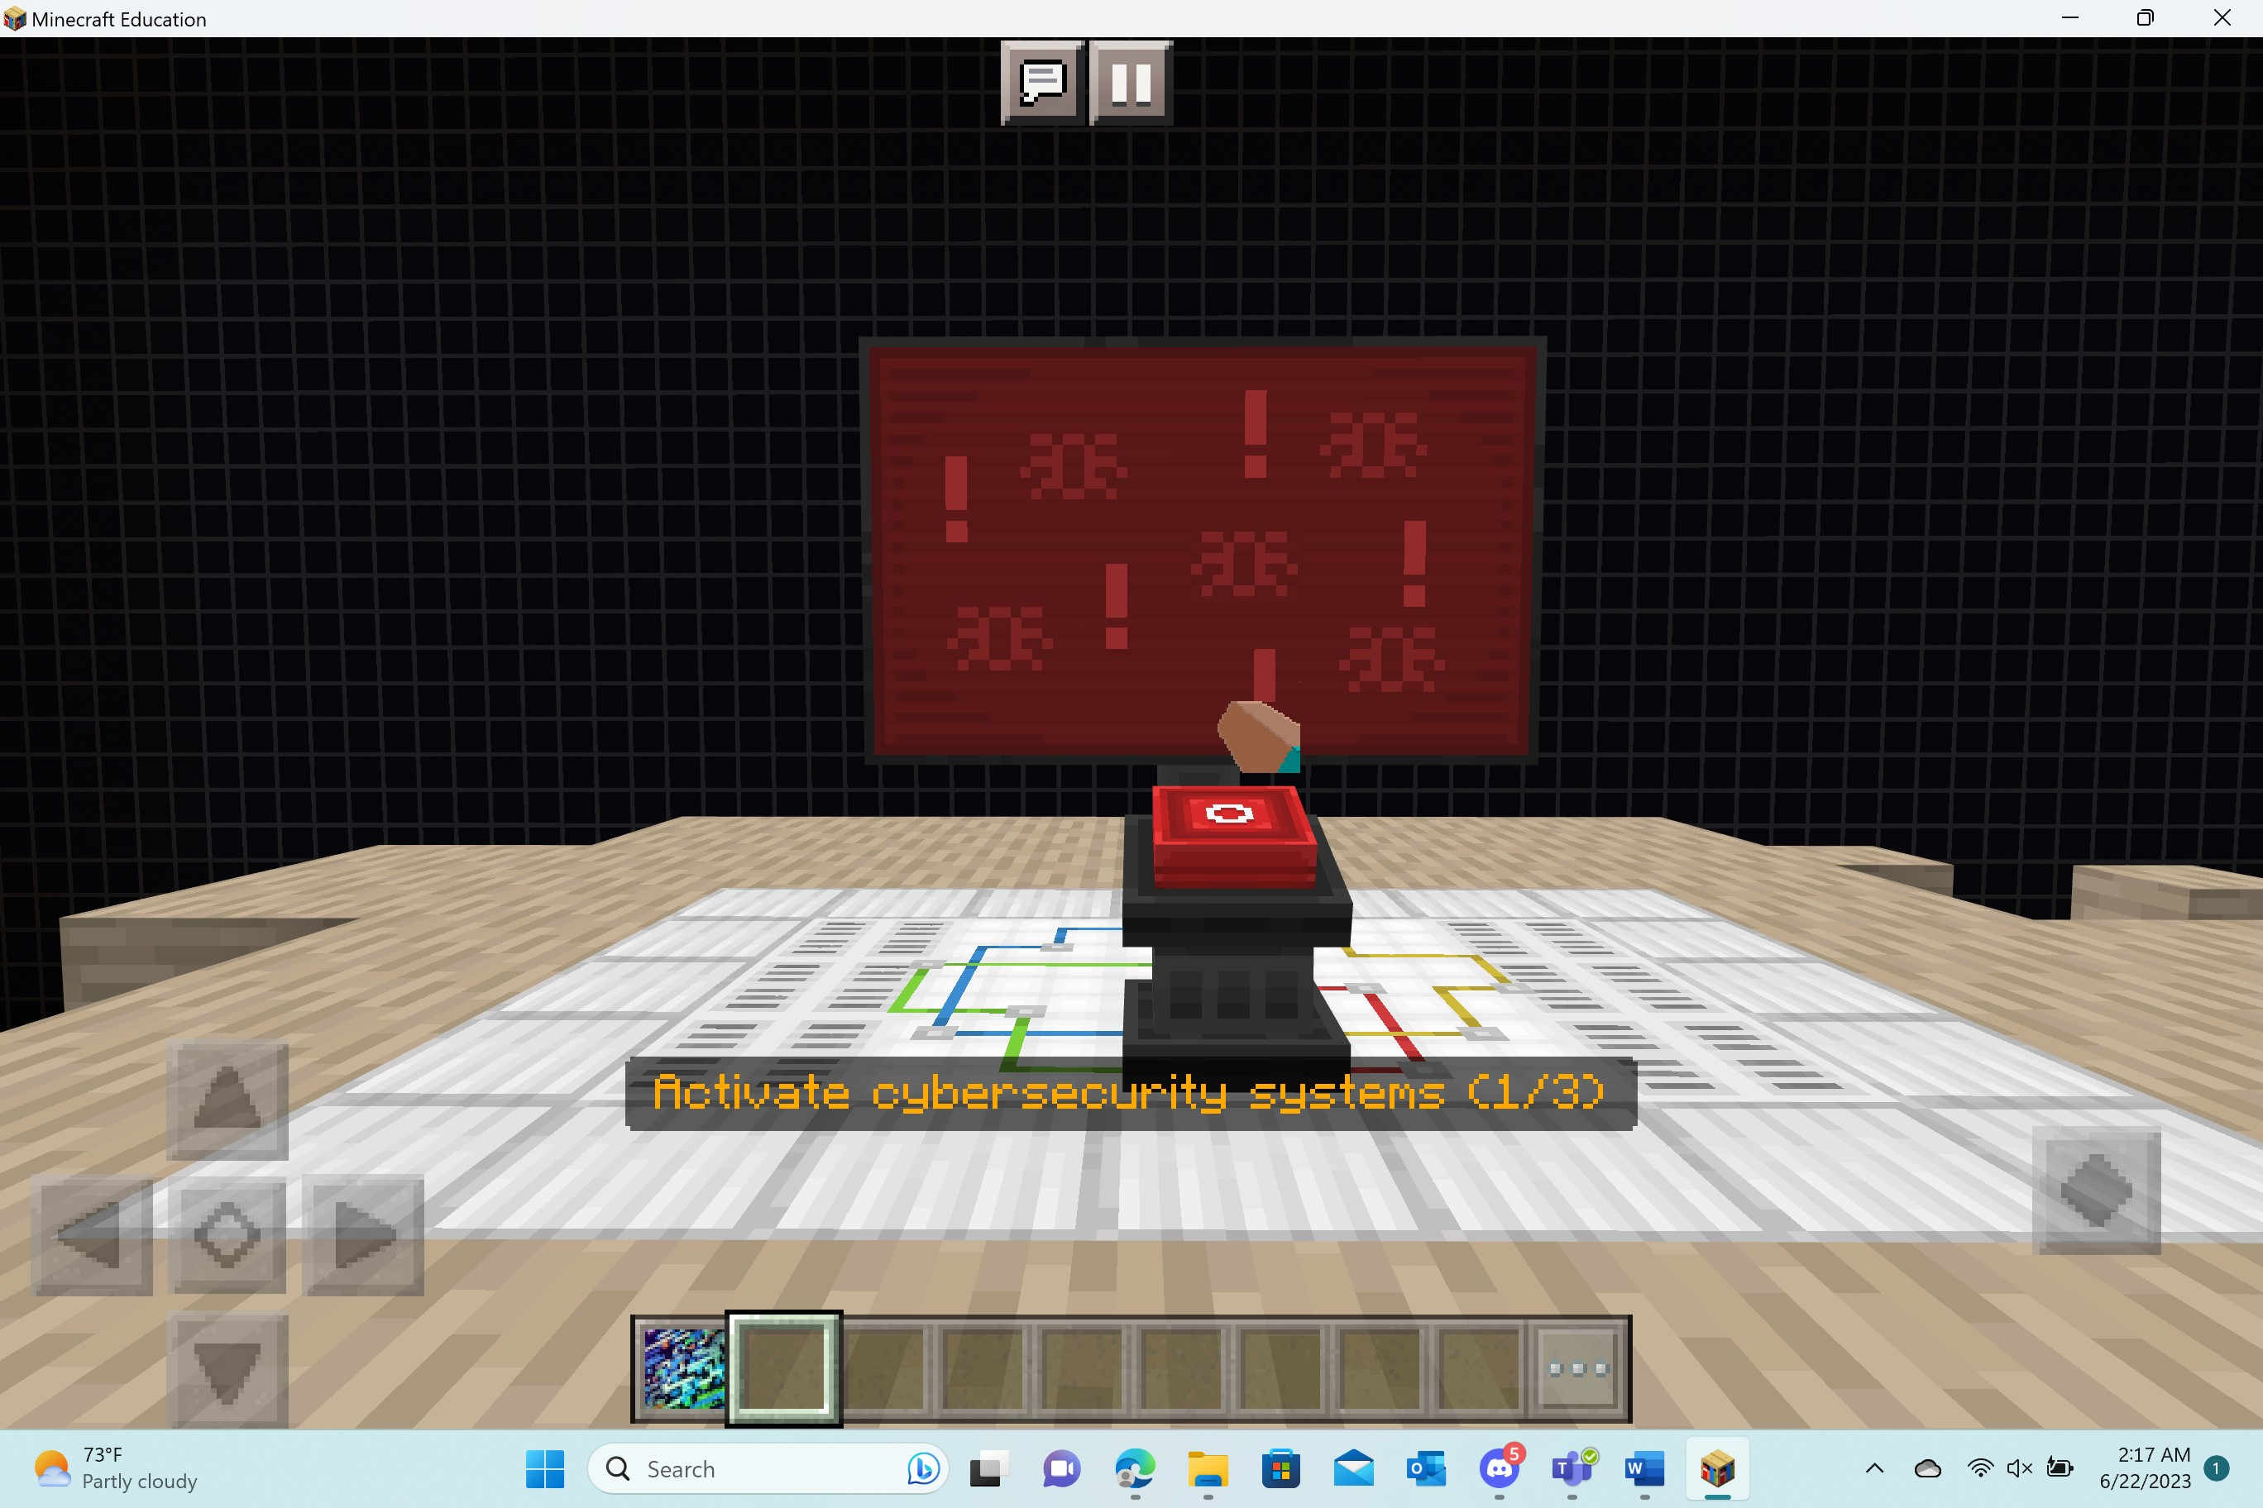 | 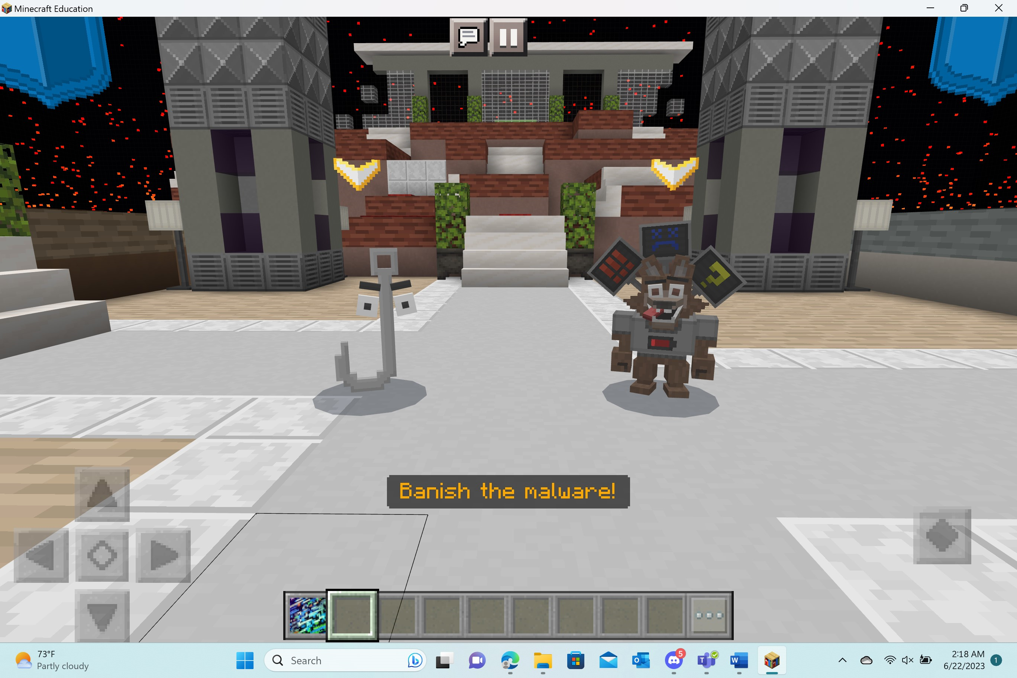

Formative Assessment
Welcome to the focus room!

Players will have the opportunity to reflect and think about what they just learned in Lesson 3. They will receive a book & quill in their hotbar. Upon opening the book, they will find the following prompts:

- What is malware?
- How do phishing scams work?
- How can you protect yourself from malware?
Players should capture their answers by turning to a new page in the book and typing directly into the blank page.

Upon completion of this world, players will receive their CyberFUNdamentals Certificate!
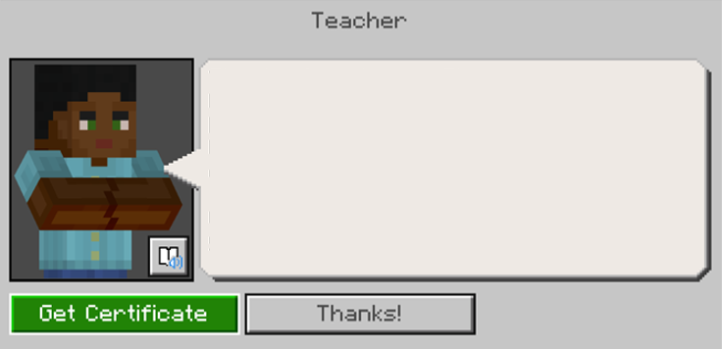

How to Get Started – Minecraft Education
Minecraft Education offers a unique learning platform where students can engage in creative builds and various game elements.

If you are licensed to use Minecraft Education through your O365 EDU account, download directly at aka.ms/download or reach out to your IT department for assistance. More information on deployment and license assignment can be found at aka.ms/meedeployguide.

Here’s how to get setup:
1. First, check here to see if your school account is eligible.
2. If you do not have a valid O365 EDU account, you can still download and try a free demo on Windows, Mac or iPad.
3. Download Minecraft Education for Windows, Mac or iPad.

Once you are set-up with Minecraft Education, you should:
- Learn about Cyber FUNdamentals with this video: aka.ms/cyberfundamentalstrailer
- Use this Educator Guide and the corresponding classroom presentation!
- Play through Cyber FUNdamentals: Network Heroes to get a better understanding of the lesson and how to navigate through the Minecraft world.

