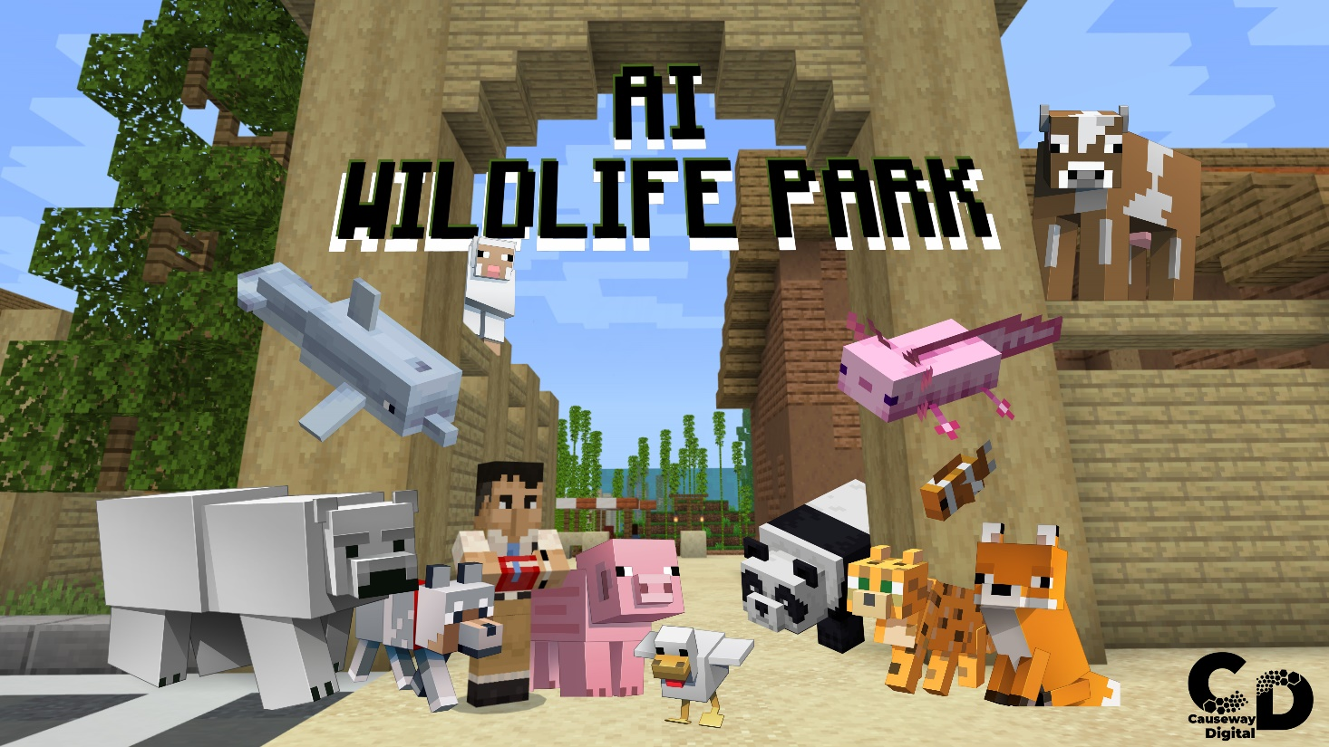

Educator Guide
AI Wildlife Park
Estimated Time: 30 minutes
Suitable ages: 9-12

THEME OVERVIEW

The wildlife park is in the process of building an Artificial Intelligence (AI) system to help feed the animals. The AI system isn’t working quite right, and this is where you come in! The wildlife park would like your help to retrain the AI system with more useful information to improve its accuracy.

This world was commissioned by the Mozilla Foundation, as part of the YouthZone at the Mozilla Festival 2023 and collaboration with Causeway Digital, as part of an effort to help introduce young people to understand the topic of trustworthy AI.

LESSON OBJECTIVES

- Explore the very basics of Artificial Intelligence.
- Explore training an AI and how this impacts the AI decisions.
- Explore how the AI decisions can be controlled.
- Explore what CAPTCHAs are and how they are used.

How to get started – Minecraft Education

Minecraft Education offers a unique learning platform where students can engage in creative builds and various game elements.

If you are licensed to use Minecraft Education through your O365 EDU account, download directly at aka.ms/download or reach out to your IT department for assistance. More information on deployment and license assignment can be found at aka.ms/meedeployguide.

Here’s how to get setup:
1. First, check here to see if your school account is eligible.
2. If you do not have a valid O365 EDU account, you can still download and try a free demo on Windows, Mac or iPad.
3. Download Minecraft Education for Windows, Mac or iPad.
Once you are set-up with Minecraft Education, you should:
- Use this Educator Guide!
- Play through AI Wildlife Park to get a better understanding of the lesson and how to navigate through the Minecraft world.
MINECRAFT VISUAL GLOSSARY
Controls  (keyboard)  keyboard buttons that help you move around and complete tasks  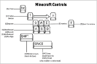 | Controls  (touch)  the touch pad that helps you move around and complete tasks  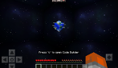 | Perspective  you can change your in-game view (i.e., perspective) by pressing function + F5  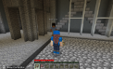
Dialog  a written conversational exchange between the player and NPC  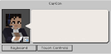 | Hotbar  selection bar that appears on the bottom of the screen  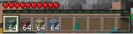 | Immersive Reader  a tool to help players in reading or translating in-game text  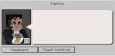
Minecraft Education  a game-based learning platform  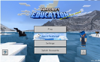 | Spawn Point  the location where a player begins game play  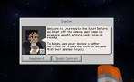

LESSON MAP

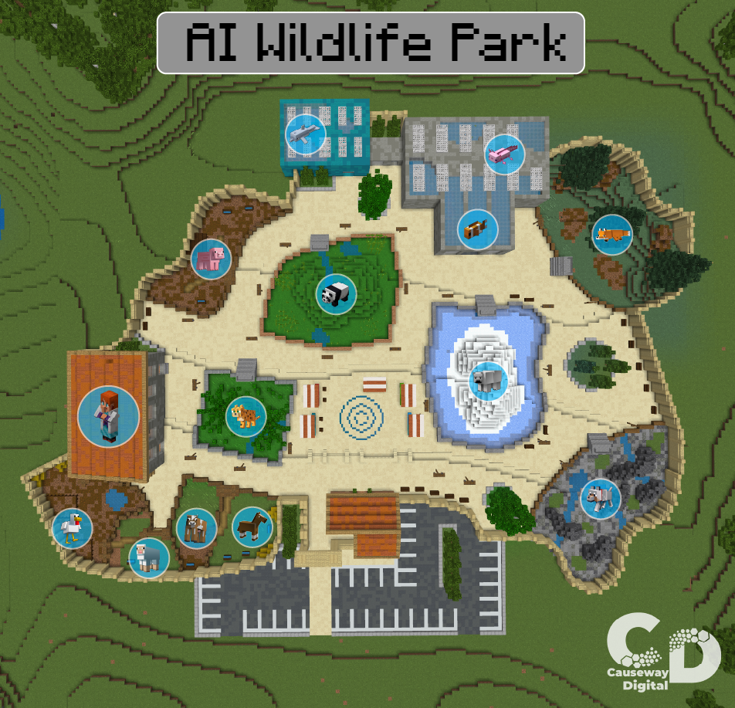

LESSON PLAN

Activity | Slide | Instruction
Introduction  Overview  Slide 2 | 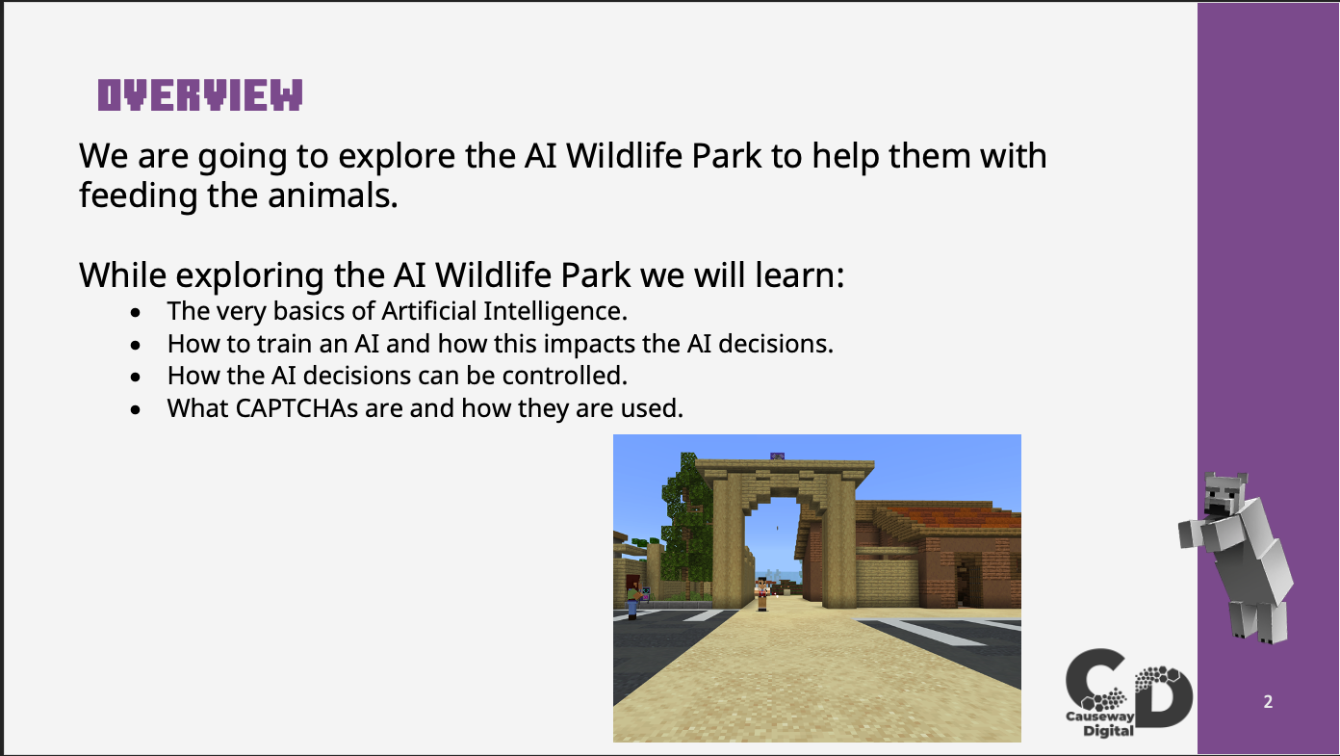 | An overview of what the world is about and what the students are required to do.
Introduction  Introduction  Slide 3 | 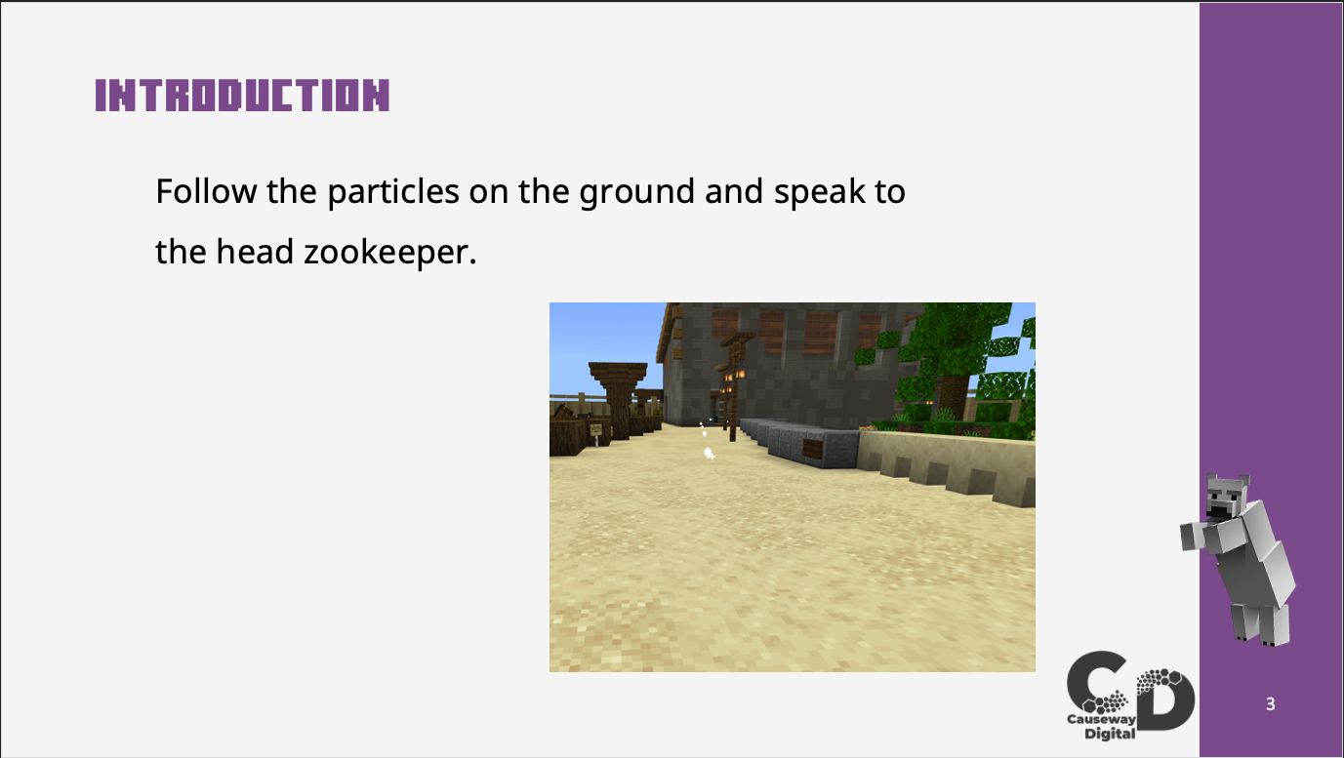 | Have the students follow the particles to speak to the head ranger.
Activity 1 – AI Testing  Testing the AI  Slide 4 | 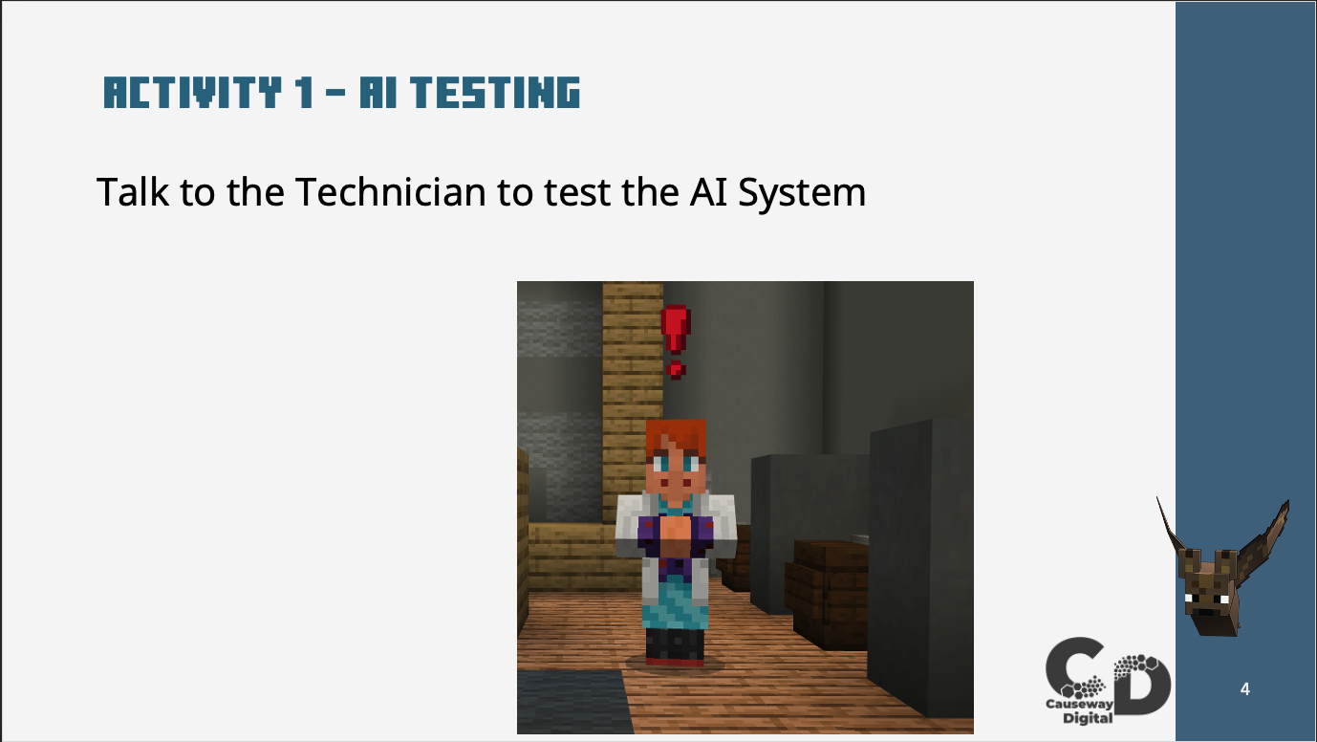 | Have the students talk to the Technician who will ask them to test the Artificial Intelligence system.
Activity 2 – Map  Map of the Wildlife Park  Slide 5 | 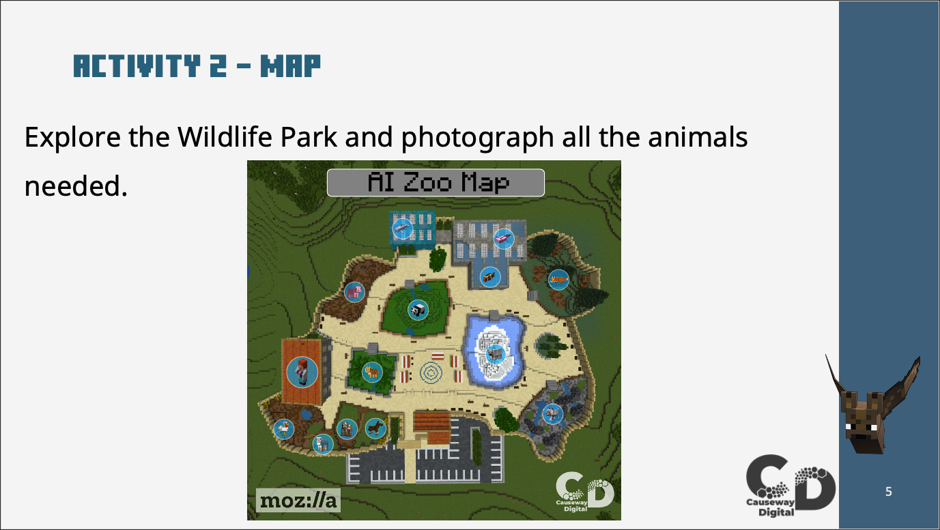 | Instruct the students that they are now going to explore the Wildlife Park and take photographs of the animals.
Activity 2 – Photographing the animals  Take pictures of the Axolotl  Slide 6 | 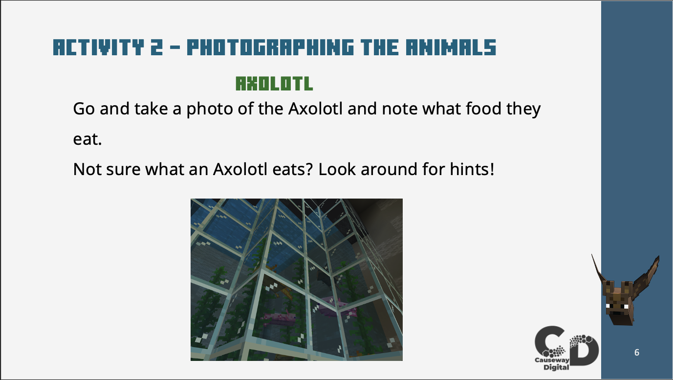 | Have the students locate the Axolotl take a photograph of them. Remind them if they don’t know what the Axolotl eat to look around for clues.
Activity 2 – Photographing the animals  Take pictures of Dolphins and Foxes.  Slide 7 | 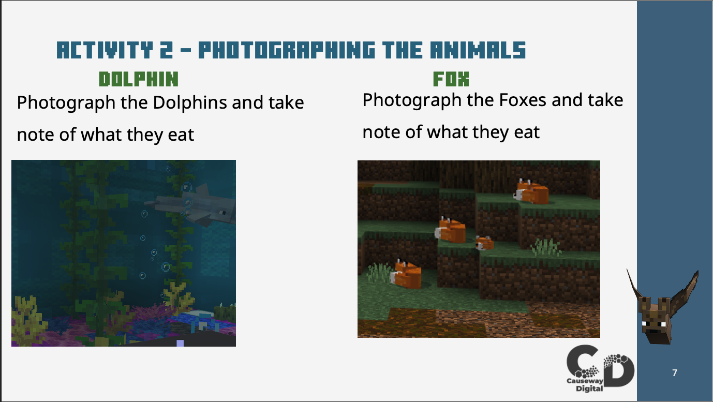 | Have the students locate the Dolphins and Foxes and take photographs of them noting the food that they eat.
Activity 2 – Photographing the animals  Take pictures of Ocelot and Pandas.  Slide 8 | 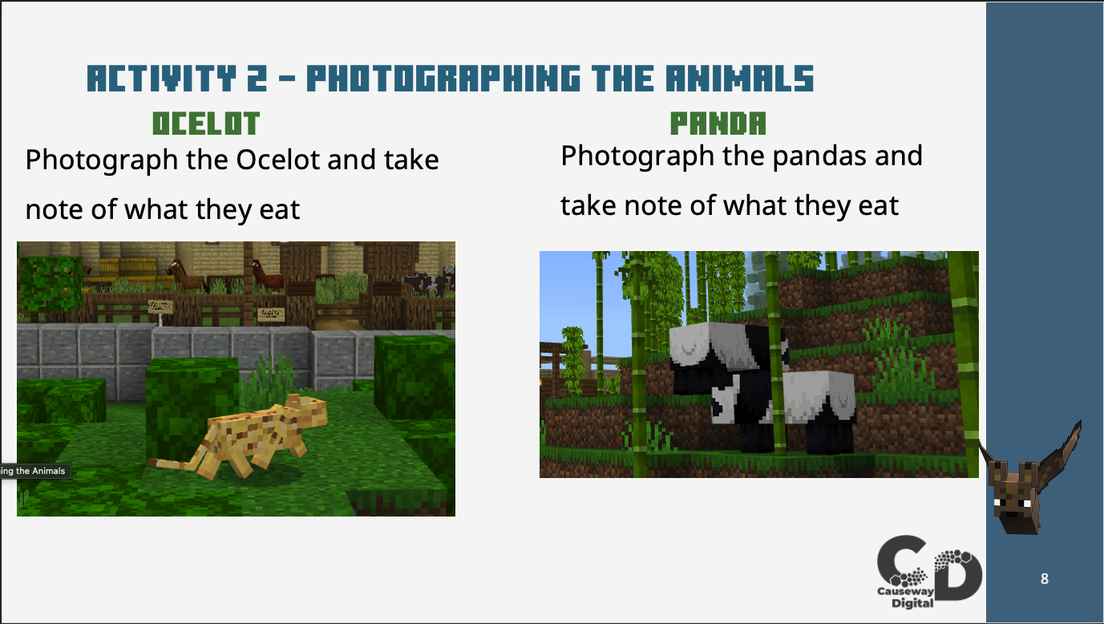 | Have the students locate the Ocelots and Pandas and take photographs of them noting the food that they eat.
Activity 2 – Photographing the animals  Take pictures of Wolves and Polar Bears.  Slide 9 | 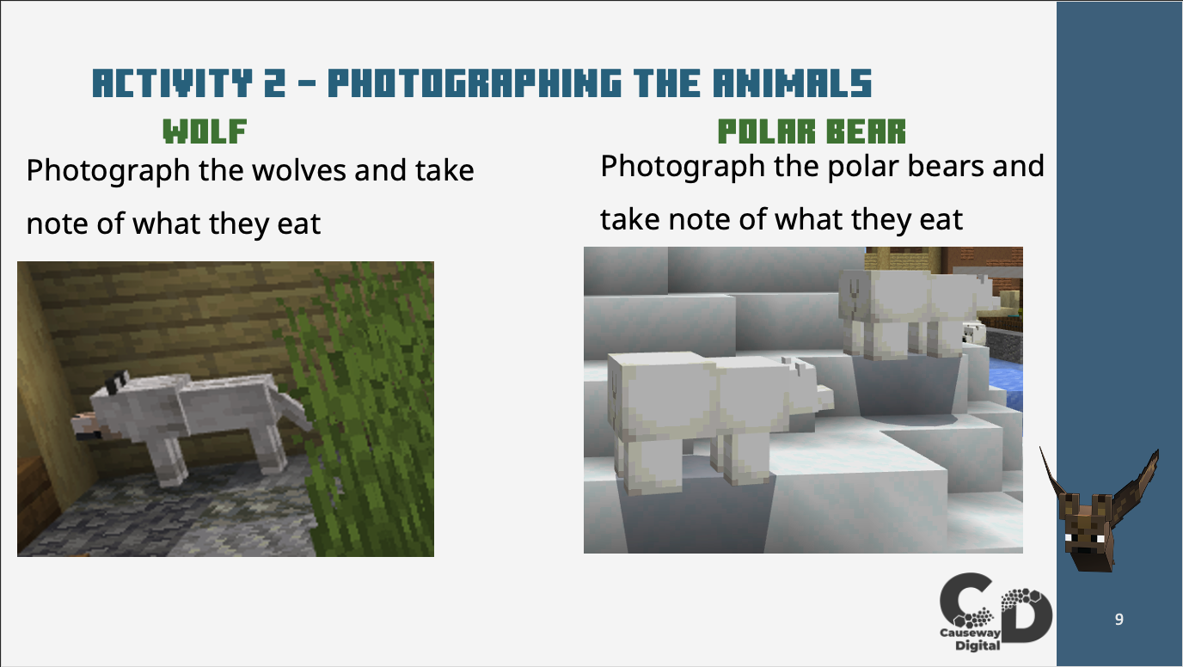 | Find the Wolves and Polar Bears and take a picture of them noting what they eat.
Activity 3 – Talk to the Head ranger  Talk to head ranger for next task.  Slide 10 | 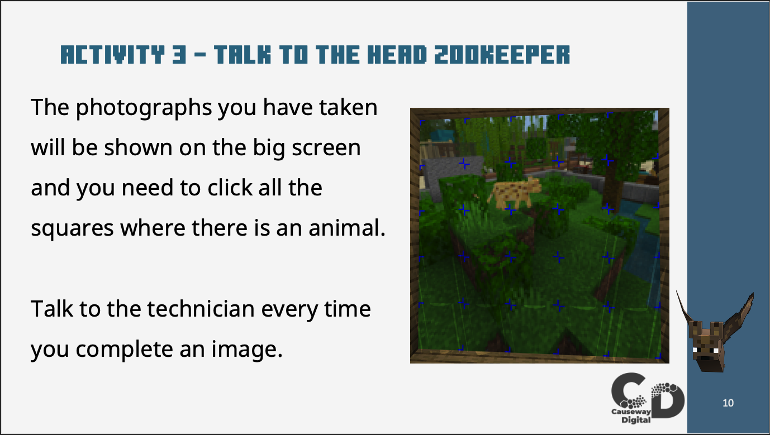 | Have the students go back to talk to the head ranger for the next task. The ranger will inform the students that new images will be shown on the big screen and the students have to click the square containing an animal or part of an animal. Talking to the technician every time they complete an image.
Active Knowledge - CAPTCHA  What is a CAPTCHA  Slide 11 | 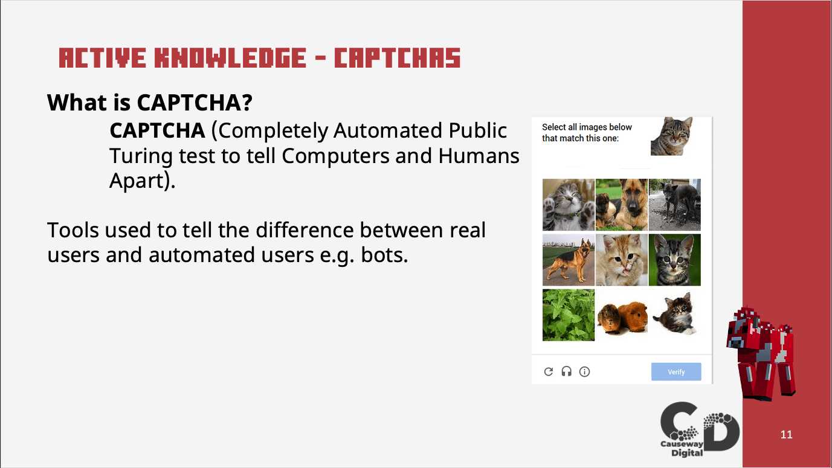 | Inform students what a CAPTCHA is
Active Knowledge - CAPTCHA  Example of Image based CAPTCHA  Slide 12 | 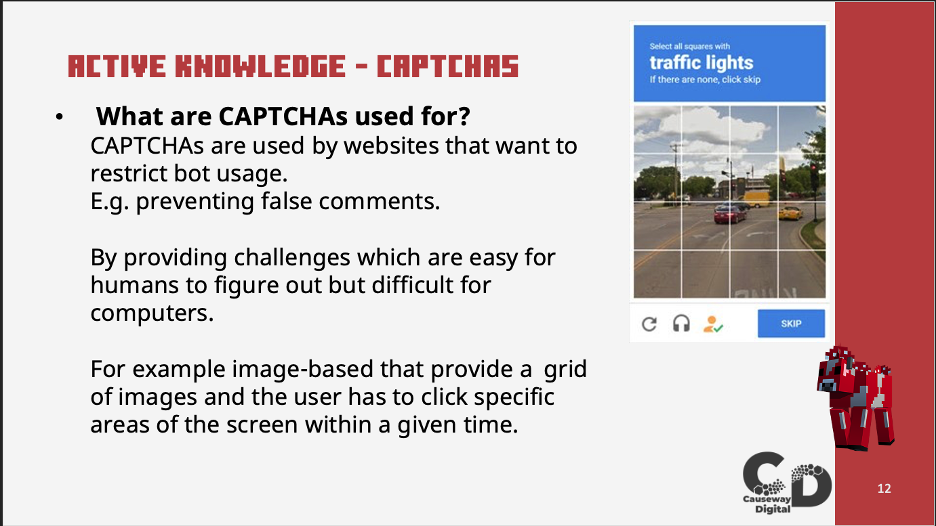 | Inform the students about image-based CAPTCHAs and how they relate back to Activity 3 within the AI Wildlife Park
Conclusion  Conclusion  Slide 13 | 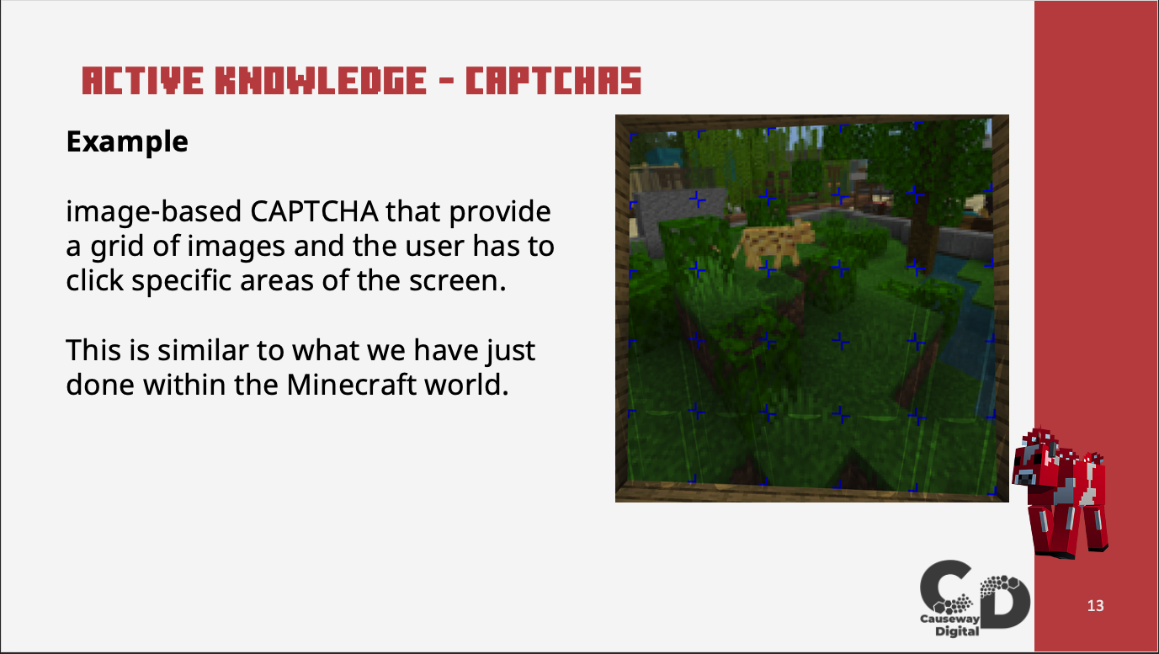 | Simple animation shown within the world of the newly trained AI feeding the animals
Knowledge Check  Knowledge Check Questions  Slide 14 | 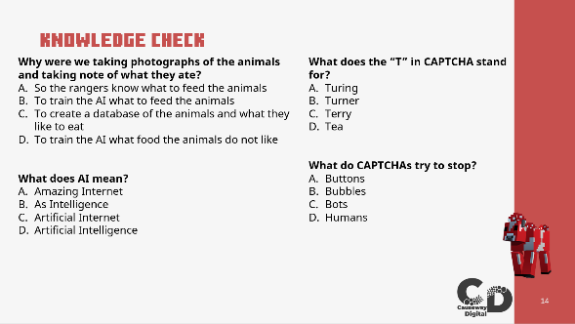 | Have the students answer the 4 questions.
Knowledge Check  Knowledge Check Answers  Slide 15 | 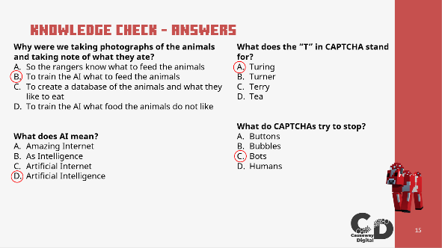 | Show the students the answers to the knowledge check
Reflection  Reflection Questions  Slide 16 | 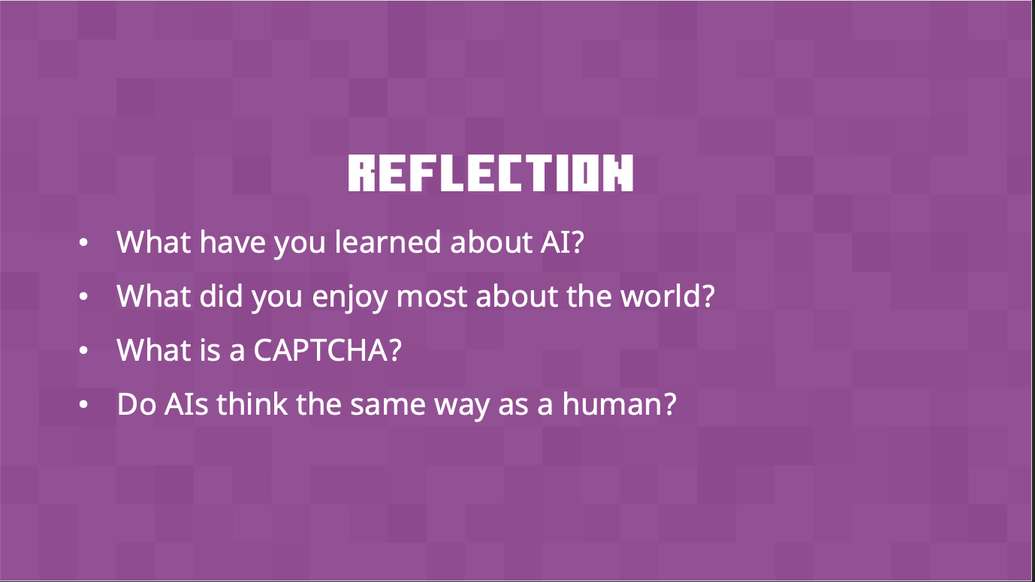 | Bring the class back together and go over what they have learned and what they enjoyed most about the lesson.

SOLUTIONS (activity 2)

The food that each animal eats.

Animal | Answers
Axolotl | Tropical Fish
Dolphin | Cod
Fox | Sweet Berries
Ocelot | Fish
Panda | Bamboo
Polar Bear | Fish
Wolf | Steak

CONCLUSION

Thank you for helping us solve our problems with our AI feeding system.

While doing this you have learned:
- The very basics of Artificial Intelligence.
- How to train an AI and how this impacts the AI decisions.
- How the AI decisions can be controlled.
- What CAPTCHAs are and how they are used.

EDUCATION STANDARDS

CSTA

2-DA-08 - Collect data using computational tools and transform the data to make it more useful and reliable.

ISTE
Knowledge Constructor
1.3.d – Students build knowledge by actively exploring real-world issues and problems, developing ideas and theories and pursuing answers and solutions.

Computational Thinker
1.5.d – Students understand how automation works and use algorithmic thinking to develop a sequence of steps to create and test automated solutions.

