

CyberSafe:
“Home Sweet Hmm”

EDUCATOR GUIDE

This Educator Guide includes:
- Getting Started
- Theme Overview
- Lesson Activities
- Visual Glossary
- Educational Standards

Introduction
Gaming is a fun and enjoyable experience. It should also be a part of a balanced life. Minecraft strives to create a place where everyone can play responsibly within the boundaries they set, free from fear and intimidation. Learning to manage screen time, social interactions, online spending, and digital citizenship are key components of being safe at home.
In order to support these key components of being safe at home, we invite you to play CyberSafe: Home Sweet Hmm. This Educator Guide is designed to provide you with information to help you support online safety for all students. This guide will provide you with an engaging game play experience that will help you find easy entry points to talk and have meaningful discussions about being safe at home. Within this guide, you will find the necessary materials to lead an intentional experience to support screen time, social interactions, online spending, and digital citizenship.
CyberSafe: Home Sweet Hmm has been designed as a fun and creative tutorial introduction to cybersecurity. This one-hour experience will provide students, ages 7-12, with fundamental principles of cybersecurity risks and demonstrate how they can be safe in digital spaces. We are committed to empowering kids with learning healthy digital habits and providing them with an active role in their learning.
This experience also offers an additional opportunity to engage with families and caregivers through a family night event. The materials to host a family night event can be found at https://aka.ms/xboxfamilysettingsapps
Let’s make the world a safer better by creating a safer Internet!
How to Get Started
- Install Minecraft: Education Edition by visiting aka.ms/download
- Learn about Safer Internet Day 2022 with this video: https://aka.ms/cybersafevideo
- Use this Educator Guide!
- Play through CyberSafe to get a better understanding of the lesson and how to navigate through the Minecraft world.

CyberSafe: Home Sweet Hmm— Theme and Activities Overview
Connect safely, game responsibly.
STOP and THINK, before you CLICK.
Many people around the world use the Internet on a regular basis. We can complete tasks online such as ordering a pizza, buying new clothes, looking up the business hours of a retail store, and checking the weather. Individuals also use the Internet to communicate and interact with others in professional, academic, and social capacities. It has revolutionized communications, to the extent that it is now one of the main mediums of everyday communication.
While the Internet has brought great efficiency and benefits to how we are able to live, work, and play, it has also created the need for additional considerations around privacy and safety. Although the Internet is usually regarded as a positive experience, it can be tricky to navigate at times. Through the CyberSafe: Home Sweet Hmm experience, students will participate in activities that will afford them opportunities to learn about common and relevant risks on the Internet.

CyberSafe: Home Sweet Hmm
Remember…
STOP and THINK, before you CLICK
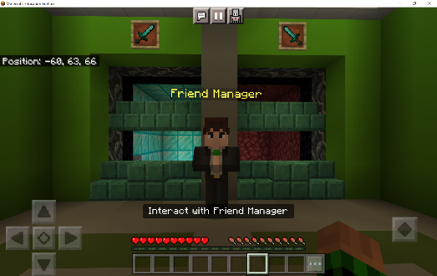  Activity 1  Griefers and trolls and strangers, oh my!  Playing online with others can be a lot of fun, but sometimes you can interact with players that are not so nice… In this activity, students will learn the importance of verifying identities of known friends, the cautionary tale of accepting unknown/wrong friend requests, and what they can do about it! | 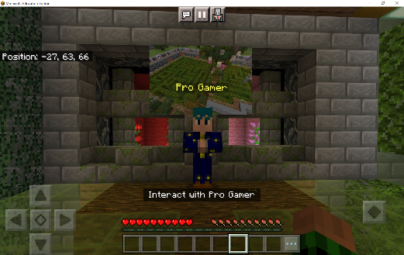  Activity 2  Is it okay to share your password?  In this activity, students will be challenged with completing a difficult maze, however, ProGamer NPC is offering them cheat codes if they provide their password. Students will learn the importance of keeping their personal information safe as it can have some serious consequences if they do not keep their information secure!
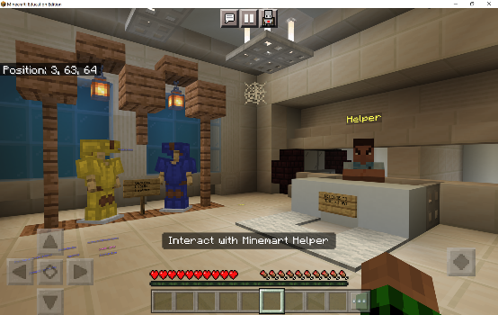  Activity 3  Ordering things online is a common and frequent occurrence for many people. However, financial and banking information can also be compromised during purchases if you are not careful! In this activity, students will receive an email message about their recent order. The email will request their account information to “fix a shipping issue”. Students will learn about the dangers of phishing schemes (i.e., when a person pretends to be part of a real company to steal your account information). | 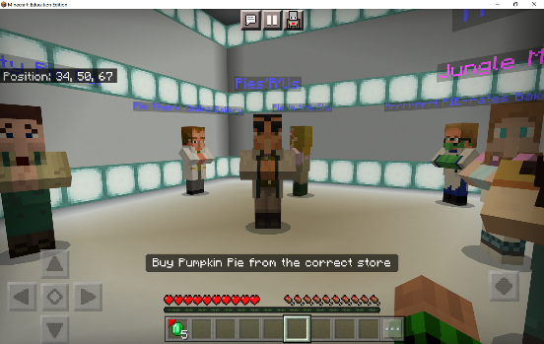  Activity 4  When we are shopping online, search engines can help us identify companies on the web! However, did you know that many times companies can pay for their company’s listing to be placed at the top of the search?! In this activity, students will learn the important of finding and verifying credibility in sources and not simply always believing everything they see or read on the Internet.

Students will exercise critical thinking to make responsible and safe decisions. As an instrumental part of this experience, trusted adults will be embedded into game play. Students should always feel confident to engage with trusted adults for help.

As part of the Safer Internet Day 2022 campaign, Xbox and Minecraft: Education Edition supports the goal to not only create a safer internet, but also a better Internet, where everyone is empowered to use technology responsibly, respectfully, critically, and creatively.

Lesson Activities
Overview of the Activities
Introduction  Activate Knowledge  (Slides 1-8) | Begin a discussion with students. Use the following questions to guide the conversation:  - What does it mean to be safe online?  - What are some common problems you have experienced (or have heard about) related to being online?  - How could you help solve these problems or even avoid these problems?
Introduction  Goal for the Day  (Slide 9) | Explain to students that they will working on CyberSafe: Home Sweet Hmm in Minecraft: Education Edition today. During this experience, their goal is to STOP and THINK before they click. We want to ensure we are making safe choices—if we are ever unsure, we should ask help from a trusted adult. A trusted adult is any grownup whose actions and words make you feel safe—this could be your parent(s), a teacher, coach, family member, etc.
Internet Safety  5 Tips for Students  (Slides 10-15) | Review each slide with students and discuss the Internet safety tips:  - Respect the settings on the device/account.  - Protect your personal information.  - Don’t believe everything you hear, read, or see on the Internet.  - Limit your screen time.  - You can always talk to a trusted adult if you need help.
Activity 1  Verifying Identities  (Slide 17) | “Want to play online with me?!”  Player will be invited to play an online game with their friend from school. The player will receive their friend’s username. When the player travels through the Internet, they will enter the game lobby. There will be 4 friend requests, which are all very similar. The player must decide which friend request to accept.
Activity 2  Protect Your Password  (Slide 18) | Online maze? I can complete it!  The player will travel through the Internet. When they arrive at the maze, there is a Pro Gamer NPC. The NPC has some cheat codes to help the player get through the difficult maze. The player must decide whether to share their login information for the cheat codes.
Activity 3  Prevent Phishing  (Slide 19) | New emerald armour?! Definitely!  The player will be informed by their Trusted Adult that they have ordered their new emerald armour from MineMart.  There seems to be a problem… The player receives a message from MineMart about a problem with their order. The player will travel through the Internet to MineMart. When they arrive, the player is told that there is a shipping issue, and the player needs to enter their account information.  The player must decide whether to provide their account information.
Activity 4  Avoiding Scams  (Slide 20) | Yummy! Pumpkin pie!  The Trusted Adult will ask the player to get pumpkin pies from the Jungle Market. When the player is using the search engine to find the web address for the Jungle Market, the player will find several different shops advertising pumpkin pie sales.  The player will choose whether to buy the pumpkin pies from the Jungle Market or choose to purchase the pumpkin pies from a different source.

Completing CyberSafe: Home Sweet Hmm
After students have completed the activities within the game, they will return back to their Home Sweet Hmm and experience the ending sequence of CyberSafe. Player will receive their new armor from MineMart.
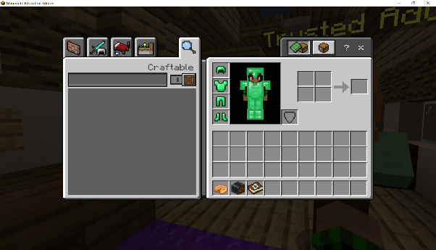
Reflection & Celebration
After game play has finished, gather students back together to recap their learning and to discuss the reflection questions. (Slides 20-21)

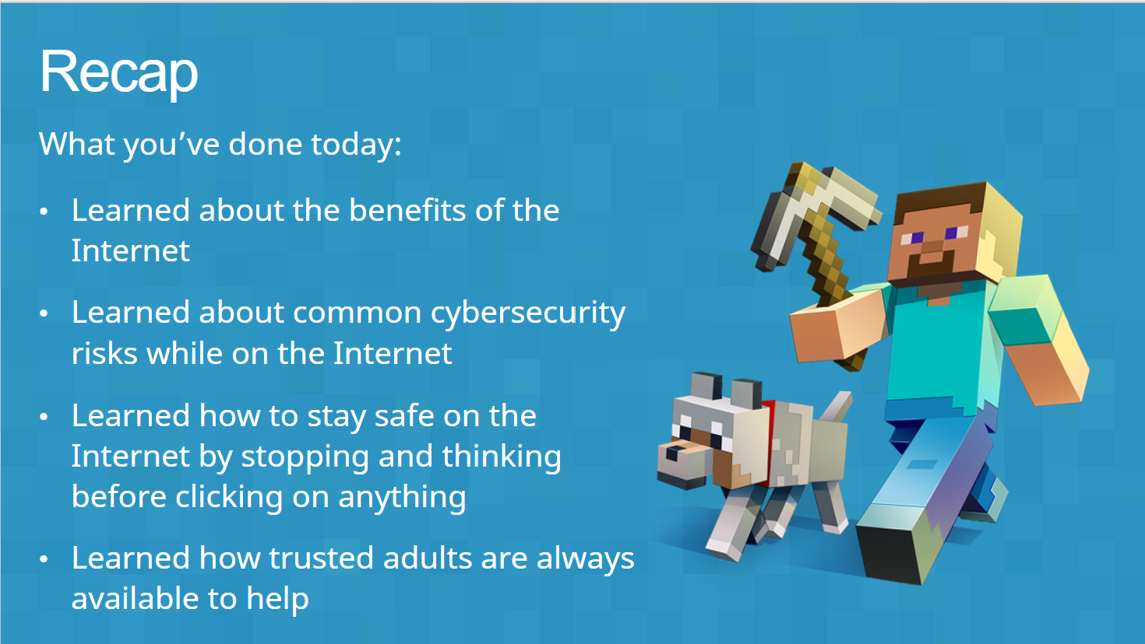

Extend the Learning
Students should then be encouraged to extend their learning about online safety and how they intend on staying safe at home. (Slide 24)
- Create a build in Minecraft of cyber safe home
- Write a song or poem to remind yourself and others to HMM… Stop and think, before you click!
- Collaborate with your peers to create a “Top 5 Safety Online” tips poster
- Participate in the Minecraft Build Challenge: Minecraft Instruction Book; create an instruction book on how to report another player if they violate the community standards

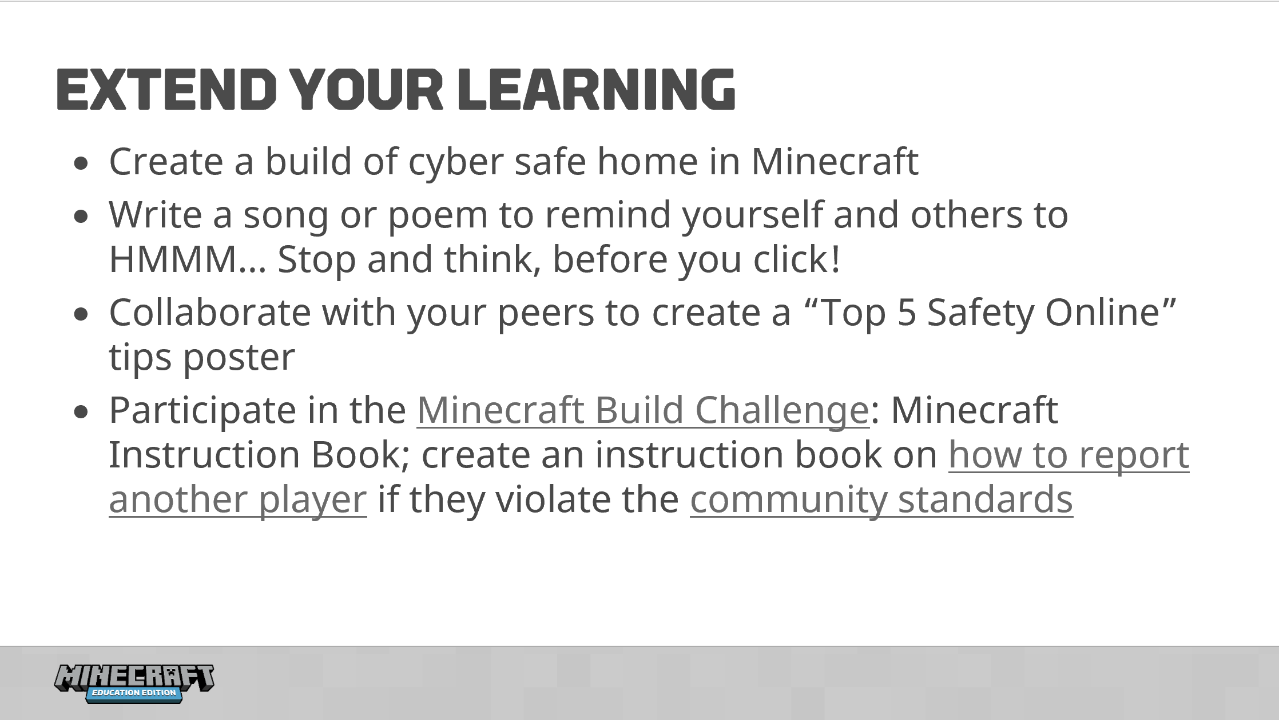

MINECRAFT VISUAL GLOSSARY
Armor  items worn by the player to protect themselves  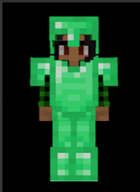 | Chalkboards  special blocks that allow you to write and display text in M:EE worlds  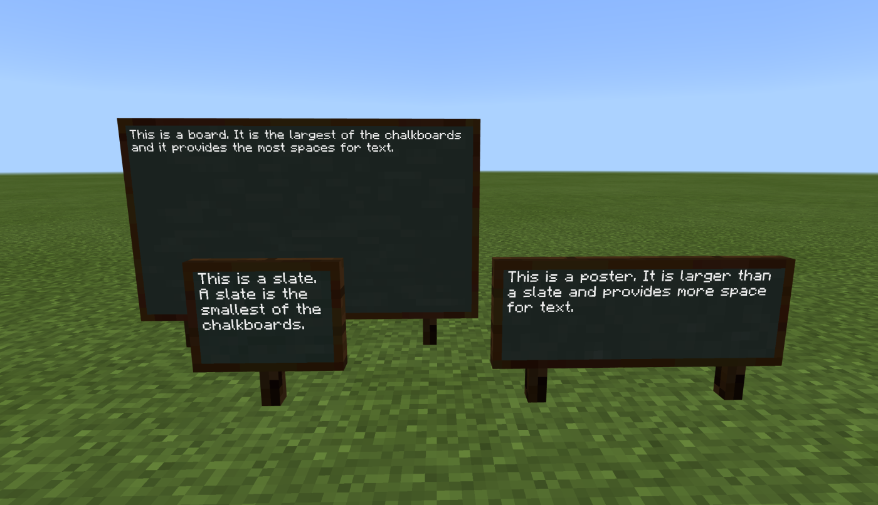 | Controls  (keyboard)  keyboard buttons that help you move around and complete tasks  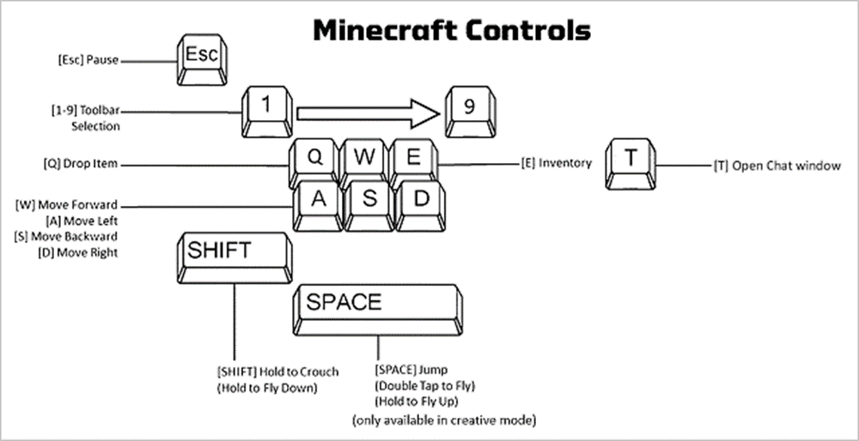
Controls  (touch)  the touch pad that helps you move around and complete tasks  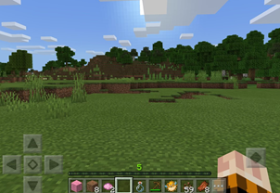 | Dialog  a written conversational exchange between the player and NPC  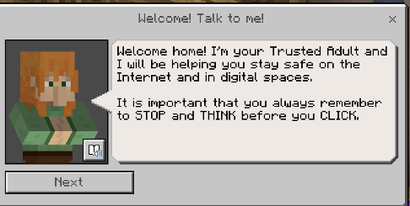 | Hotbar  selection bar that appears on the bottom of the screen  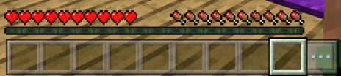
Immersive Reader  a tool to help players in reading or translating in-game text  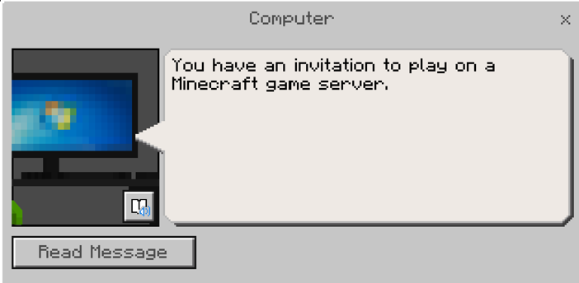 | Minecart  a vehicle that players can use to ride in on top of a rail system   | Minecraft: Education Edition  a game-based learning platform  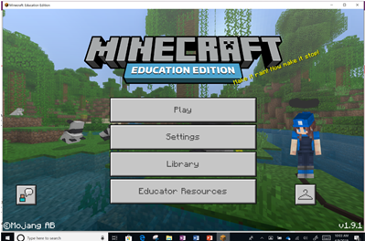
NPC  non-player character  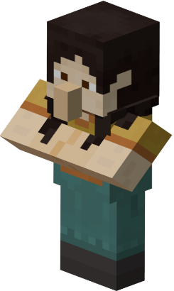 | Spawn Point  the location where a player begins game play  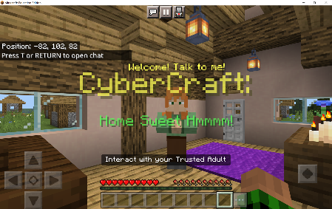 | Trusted Adult  the NPC character who you have a good relationship with  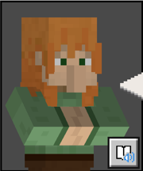
CYBERSECURITY GLOSSARY
Account  an identity created for a person in a computer, website, app, or other program  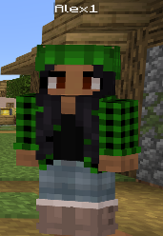 | Friend Request  request comes from someone who wants to connect with another person online  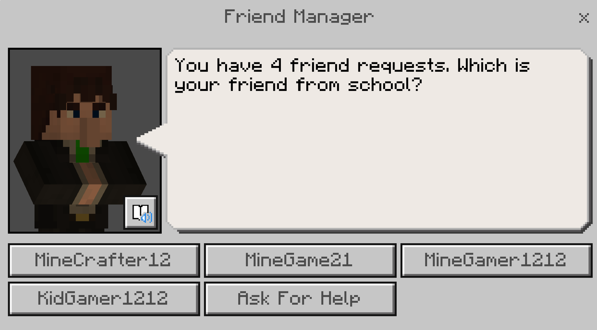 | Login Information  a set of credentials used to authenticate a user  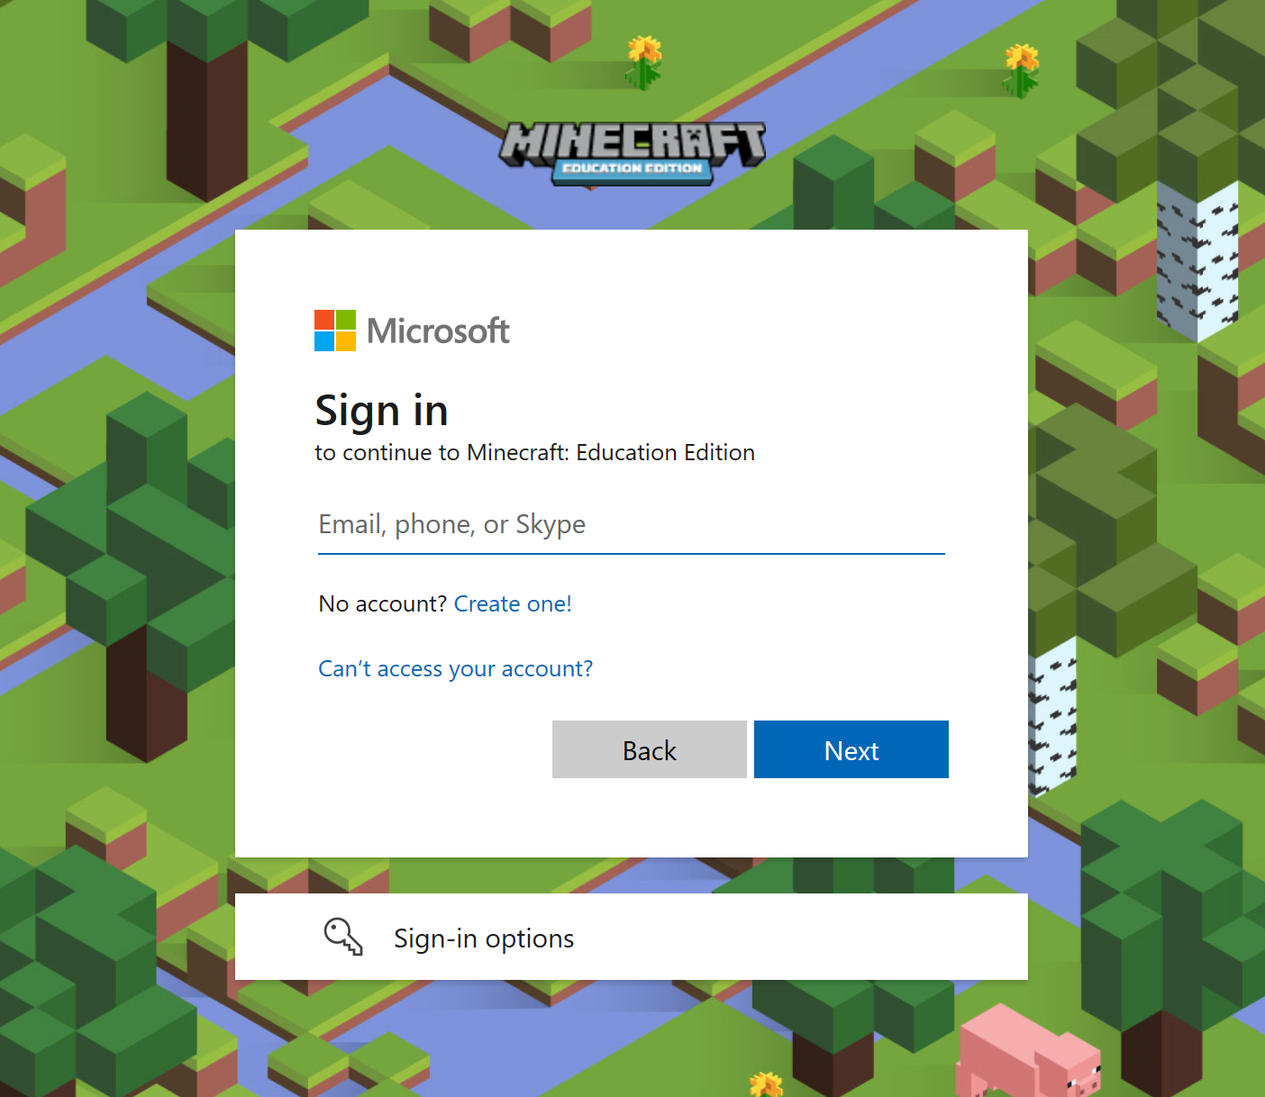
Internet  a network, or system, that connects millions of computers worldwide  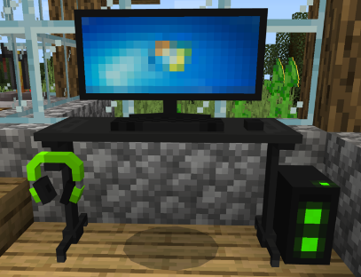 | Password  a secret word, phrase, or group of numbers that a person must know to gain access to an account  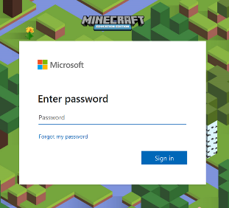 | Personal Information  information that directly identifies an individual (e.g., name, address, phone number, social security number, etc.)  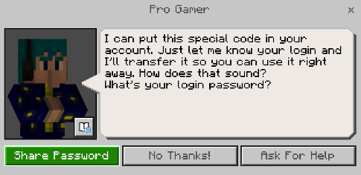
Phishing  attempt to get people to share their personal or financial information  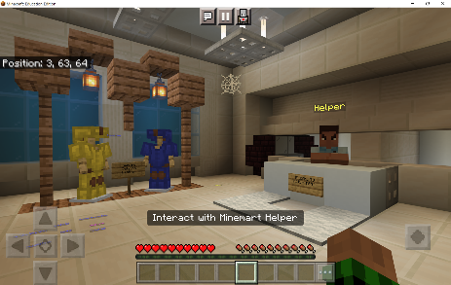 | Public Information  information that is not considered confidential or personal   | Risk  anything that may cause damage to the confidentiality, integrity, or availability of your data  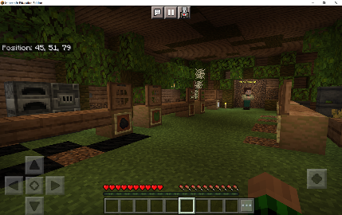
Safety  anything that people do to protect themselves or others from harm, loss, or danger   | Scam  a sneaky or dishonest plan that's meant to trick someone  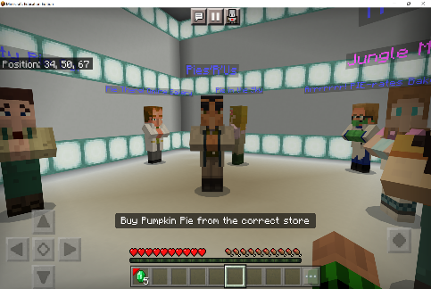 | Username  a combination of letters and often numbers that identifies a user  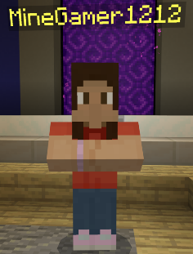

Educational Standards
Standards
United States | Australia | UK - England
Keep login information private, and log off of devices appropriately.  1A-IC-18 | Considering ways of managing the use of social media to maintain privacy needs  ACTDIP013 | Use technology safely and respectfully, keeping personal information private; identify  where to go for help and support when they have concerns about content or contact on  the internet or other online technologies.  Computing: Key Stage 1
Discuss real-world cybersecurity problems and how personal information can be protected.  1B-NI-05 | Discussing digital citizenship rules and behaviours for participating in an online environment  ACTDIP013 | Use technology safely, respectfully and responsibly; recognise  acceptable/unacceptable behaviour; identify a range of ways to report concerns about  content and contact.  Computing: Key Stage 2
Work respectfully and responsibly with others online.  1A-IC-17 | Making ethical decisions when faced with reporting inappropriate online behaviour or acknowledging digital products created by others  ACTDIP013 | Understand a range of ways to use technology safely, respectfully, responsibly and  securely, including protecting their online identity and privacy; recognise inappropriate  content, contact and conduct and know how to report concerns.  Computing: Key Stage 3
Explain how physical and digital security measures protect electronic information.  2-NI-05 | Applying safe practices while participating in online environments  ACTDIP022
Developing a set of ‘rules’ about appropriate conduct, language and content when communicating online, and using these rules as a basis for resolving ethical dilemmas

ACTDIP022

